Regulation of the work ability in small and micro enterprises through multimedia tools

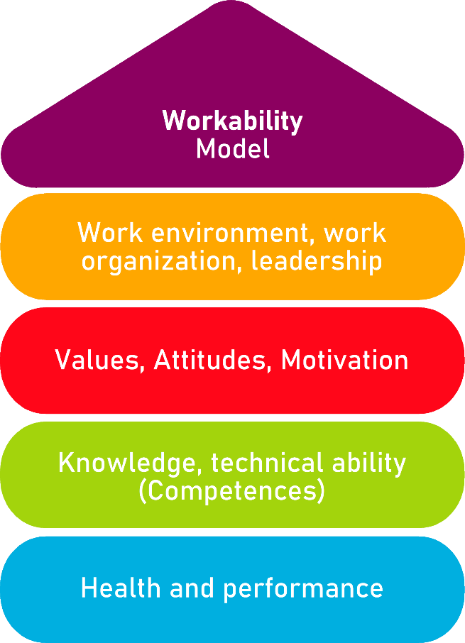

Tool 30
What kind of leader are you?

Description of the aim________________________________________________________
This tool allows the identification of existing leader typologies. Managers can assess their aptitude and behaviour by taking part in the questionnaire, so that they can reflect on their work and their relationship with their employees. Below you will find the description of each profile and you will identify yourself with one or more of them, following Daniel Goleman's theory, according to which different types of leaders can coexist in each person.

Target group
Employers of micro and small enterprises.
Benefit of the tool____________________________________________________________
The benefit of the tool is to analyse one's own attitude as a manager, reflect on it and understand how to improve. The manager will be able to adopt some behaviours, inspired by each profile, so that he/she will be able to understand the best way to approach and deal with each situation, leading to an improvement in his/her work management.

Duration
This tool can be developed in approximately 20 minutes.
How to use the tool
To take advantage of the tool, the manager will start by filling in the form. It presents six tables that determine a leader typology, to which he/she can answer by marking: strongly agree, agree, neutral, disagree or strongly disagree. At the end of the questionnaire, you will be able to find out which are the typologies of leaders, their characteristics and with which you agree. In this way, you will know which leader you are and how you could improve your management skills.

Type of leader: 1 | Strongly agree | Agree | Neutral | Disagree | Strongly disagree
Communication is a fundamental quality for a leader, firstly to express clearly his ideas to employees, to be empathetic, to give indications on tasks and objectives to be achieved, and secondly, to establish a good relationship with the team, to understand them, to take their opinion into account and to value it.

Type of leader: 2 | Strongly agree | Agree | Neutral | Disagree | Strongly disagree
A leader must understand which are the talents of each employee, in order to exploit, develop and value them. At the same time, he or she must identify weaknesses, so that the employee can learn and strengthen the weak points. Therefore, one of the main responsibilities of a leader is to value, sustain and stimulate team cohesion.

Type of leader: 3 | Strongly agree | Agree | Neutral | Disagree | Strongly disagree
The harmony, teamwork, satisfaction and serenity of each employee are the key to success. In order to work effectively, it is necessary to maintain a good working environment that favours the work of each individual, as well as to resolve any misunderstandings or disputes that may arise, before they affect the balance between the team and, consequently, productivity.

Type of leader: 4 | Strongly agree | Agree | Neutral | Disagree | Strongly disagree
The hard work of all employees is the best way to achieve great results, for the development of each individual and of the company.
In addition, when making a decision, all the pros and cons must be weighed up, and feedback must be requested from the team as well as their point of view.

Type of leader: 5 | Strongly agree | Agree | Neutral | Disagree | Strongly disagree
Ambition is one of the most important traits of a leader. He or she has to achieve great results in order to make the company successful, establish and develop a strategy to achieve this goal. To do so, he has to create a healthy competition between departments to stimulate the work of each employee.

Type of leader: 6 | Strongly agree | Agree | Neutral | Disagree | Strongly disagree
The goal of a leader is to achieve success, which means implementing strategies, business plans, changes and everything necessary, including imposing them on employees to achieve the final result. The leader will have to analyse the process, make sure that everything is done according to the established times and phases, encourage the employees and focus them on the objective, so that their work is efficient and the business is profitable.

Leadership typologies | Characteristics
1) Visionary Leadership | The visionary leader is empathetic, strongly believes in his or her perspective and that the work of each person is essential to achieve the objectives.  This profile is suitable when it is necessary to adapt to changes and to face them, especially when adapting to these changes implies the improvement of the company and its employees.
2) Leadership Coach - Guidance | The coach-guidance leader helps to strengthen weak points and values the talents and desires of each employee, matching them with the mission and vision of the company. He establishes a good relationship with the team, encourages communication, is a skilled motivator and a good listener.  This profile is appropriate when there is a need to support the professional development and competences of the employee.
3) Affiliative Leadership | The affiliative leader focuses a lot on the well-being of the team, ensures a good atmosphere, harmony and good relations between everyone, resolves conflicts when they arise, is empathetic and encourages the team.  Their profile is successful when it comes to mediating, keeping stress under control, motivating and strengthening interpersonal relationships.
4) Democratic Leadership | The democratic leader values the contribution of employees and ensures their participation; he collaborates, works with the team and listens to them.  This type of leader is the one who is best at drawing out the contribution of all team members, supporting them and achieving general consensus.
5) Leadership Who sets the guidelines | The leader who sets guidelines focuses mainly on achieving objectives, is not very empathetic, but rather impatient, and is not very cooperative, but is known for being able to take the initiative.  This profile is perfect for achieving challenges and goals, their attitude allows them to create a qualified team.
6) Dominant Leadership | The dominant leader commands the team, checks, controls and threatens. He does not favour the relationship with others, but distances him from himself.  His attitude is a winner when a crisis has to be managed and resolved.

Checklist: Action plan
What is to be done? | How (procedure)? | Cost estimation | Priority | Until when? (date) | Who is responsible?
General analysis | At the end of the questionnaire, you will have to read and analyse the characteristics of each typology of leader. |  | ☐ high  ☐ medium  ☐ low
Self-evaluation | You will continue to self-assess your work, skills and conduct with respect to work and team management. |  | ☐ high  ☐ medium  ☐ low
Reflection | Reflection will allow you to understand which behaviours are appropriate, which ones you should review and, above all, to understand what is the best approach for each situation. |  | ☐ high  ☐ medium  ☐ low
Improvement | Having understood your successes and failures, you will need to implement changes to be a better leader. |  | ☐ high  ☐ medium  ☐ low

