Regulation of the work ability in small and micro enterprises through multimedia tools

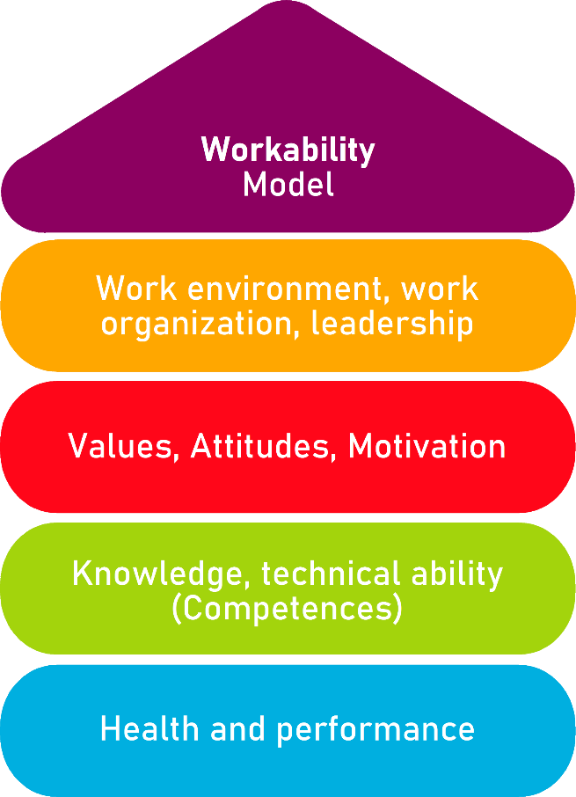

Tool 32
Labour Risk Prevention

Description of the aim
This tool is useful for young employees to be aware of labour risks that can occur at the workplace and to know how to prevent them. The working environment can cause safety hazards for workers, represented by ladders, computers or other IT equipment. In these cases, the attitude of the worker is fundamental, in fact, in order to prevent risks, he or she should always use the equipment and working tools correctly and inform a superior if there are risks. With the following guidelines, young workers and their managers will receive recommendations concerning safety in the office, the preventive measures they can follow to avoid risks and hazards, and to ensure appropriate working arrangements for the worker.
Target group
Managers and Young workers.
Benefit of the tool
Thanks to the guidelines offered by this tool on occupational risks and their prevention, managers and young workers will have information and a reference to check their compliance with the requirements. To make this more visual and easier, they can tick the boxes in green, blue and red. The first one, the green one, helps them to indicate that everything is correct and that they already comply with the requirement; the second one, the blue one, indicates that something needs to be added/changed; the red section, on the other hand, should be ticked to indicate that new measures need to be taken and concrete changes need to be implemented in order to comply with the guideline
Duration
This sensibilisation tool is useful for managers and young workers, so that they know the labour risks and how to prevent them. By investing 30 minutes in reading and analysing the tool, they can improve their own safety at work and that of their colleagues.
How to use the tool
The following guidelines are arranged in 4 areas:
- Risks in the management of young talent.
- Risks at the office.
- Risks and prevention.
- Postural hygiene.
- Workplace measures.
The first step is for the company managers to read the guidelines and tick the box in green, blue or red, depending on the measures taken in their company. In this way they will be able to identify which guidelines are already in place, which ones should undergo minor changes and which ones need to be radically changed. This will allow them to quickly and visibly identify what needs to be done and they will be able to make a "to do list" to identify the measures they will need to implement to ensure safety in the workplace. In addition, the managers should also provide the guidelines to the employees, so that they can take note of them and take care of themselves.

Risks in the management of young talent | True  (No action is required) | Partially true  (A partial action is required) | False  (A specific action should be implemented)
Young workers, when starting their work experience, need guidelines to make it easier for them to adapt to the new job. In fact, the manager or a mentor chosen by the company should take care of the new employees by helping them to integrate into the team, to feel part of it and to be receptive to the tasks to be performed.
The company should provide training and support to young employees so that they learn effectively how to develop their role and duties in the company.
It is important that the employee is integrated into the team, in order to favour his or her relationship and work in the team. To achieve this objective, the manager or tutor should assign tasks to be developed with other members of the team, so that the newcomer can have confidence in himself and in his colleagues, improving the quality of his work.
It is recommended to share the organisation chart of the company and the contacts of colleagues with young employees, in order to better introduce them to the company itself.
In order to favour the incorporation of the new employee, it is recommended to give him/her tasks with established dates so that he/she can get organised in their development, avoiding stress and demotivation.
It is recommended to welcome new employees by preparing their workspace, introducing them to the equipment and showing them around the office, providing them with all the information about their corporate email, the access codes to the wifi and other systems used by the company, the working hours, giving them a uniform if necessary and having them sign any pending and necessary paperwork.
Sharing and clearly explaining the mission and vision of the company will help the new employee to adapt, integrate and better understand the values of the company to which he/she belongs. At the same time, the manager will have to inform the new employee in a clear and detailed way about the tasks and the role he/she will play, in order to achieve a good integration.

Risks at the office | True  (No action is required) | Partially true  (A partial action is required) | False  (A specific action should be implemented)
In work and traffic areas, everything must be kept in its place, to avoid creating obstacles when walking that could lead to falls. This also applies to cables, which must not be in walking areas.
In the office, objects or furniture can be knocked unintentionally, so it is recommended to fix them to the floor, distribute the weight inside them and make sure they are well secured. In the event of a tipping over, it is advisable to think first of your own safety, move away and do not try to hold the furniture.
It is recommended to be careful with computer equipment and not to use it when water can reach it. In case of an accident or malfunction, the electricity should be turned off. If this is not possible, it should be done using something insulating (remember that insulating materials are: wood, rubber, plastic, glass, paper), and if there is someone affected by electricity, it is recommended not to touch that person.
Pay attention to doors: glass doors that are not very visible should be marked with a sticker or a sign, swing doors should be opened with caution and it is important to leave the passageway to emergency doors clear.

Risks and prevention | True  (No action is required) | Partially true  (A partial action is required) | False  (A specific action should be implemented)
Office jobs that require sitting in a chair at a desk and using a computer involve potential health risks, such as eye strain, postural fatigue or mental fatigue.
Visual strain manifests itself through symptoms such as: discomfort, blushing, tearing, dry and itchy eyes, difficulty in vision, migraine.
The causes of eyestrain are: inadequate lighting, spending too much time in front of devices such as computers, television, mobile phones, tablets, etc.
Symptoms of postural fatigue are: headache, neck, arm, hand, and lower back pain, contractures and poor sensitivity in the limbs.
The causes of postural fatigue are: incorrect sitting and computer posture, repetition of the same movements, furniture that does not respect the recommended measurements for the work activity, inadequate lighting, bad habits in daily life.
Mental fatigue can manifest itself in the form of: sleep disturbance, restlessness, tiredness, migraine, discomfort in the digestive system in the form of diarrhoea and/or nausea.
The origin of mental fatigue can be found in the workplace and can be caused by stress and worry about the tasks to be performed, the role in the company, inadequacy, difficulty to be integrated in the team, social and/or psychological reasons.

Postural hygiene | True  (No action is required) | Partially true  (A partial action is required) | False  (A specific action should be implemented)
It is recommended to use a screen that can be adjusted in height and inclination, so that it adapts to each worker. The screen should be placed in front of the worker, at a distance of between 50 and 65 cm and at a height that guarantees correct vision, and it should also have an inclination of between 10° and 20°.
The keyboard should be positioned away from the screen, firm on the table and allow both hands to rest on the lower edge.
The table should be large enough to allow the worker's legs to fit underneath and to allow the worker to change posture and to have space to rest both forearms. It is also advisable that the height can be adjusted, the recommended dimensions are: 70 cm wide, 70/75 cm high and 60 cm deep.
The chair should have an armrest, 5 legs to support the weight evenly, the possibility to adjust the height of the seat and the inclination of the backrest to support the worker's back correctly.

Workplace measures | True  (No action is required) | Partially true  (A partial action is required) | False  (A specific action should be implemented)
The lighting of the workstation is a very important element to take into account. Whenever possible, it is recommended to position the desks close to the windows and to use curtains to dim the light. However, windows cannot be the only source of light, because depending on the time of day and the weather, they do not always provide the same amount of light, so a source of artificial light should also be provided.
Artificial light should be regulated in order to avoid reflections and high contrast between the illuminated and unilluminated areas, as this could cause discomfort to the worker's vision, migraines and lack of concentration.
Worker concentration can be affected by noise, which should not exceed 65 dB for activities that do not require a lot of attention and concentration, and 55 dB for activities that do. To reduce noise in the workplace, wooden screens can be used to separate the environment.
In the office, the temperature must be taken into account. Where sedentary activities are carried out, the recommended temperature is between 17ºC and 27ºC, depending on whether it is summer or winter. On the other hand, where activities involving movement are carried out, the ideal temperature is between 14ºC and 25ºC.

Checklist: Action plan
What is to be done? | How (procedure)? | Cost estimation | Priority | Until when? (date) | Who is responsible?
Welcome the employee and encouraging his or her integration into the company and the team. | The manager or mentor will have to give him/her all the information about the company, introduce him/her to the team and check that he/she is integrated into the team. |  | ☐ high  ☐ medium  ☐ low
Provide access to the necessary tools. | Provide access data to email, platforms used, wifi and all the tools the employee may need. |  | ☐ high  ☐ medium  ☐ low
Ensure worker safety. | The company will have to train the employee on labour risks and provide him/her with measures to prevent them. |  | ☐ high  ☐ medium  ☐ low
Train the employee. | The company will be responsible for training the employee so that he/she has the necessary knowledge to carry out his/her role in the company. |  | ☐ high  ☐ medium  ☐ low
Integrate the employee into the team and the company. | Provide the necessary guidelines on the company. |  | ☐ high  ☐ medium  ☐ low

