**Regulation of workability in small and micro enterprises through multimedia tools**

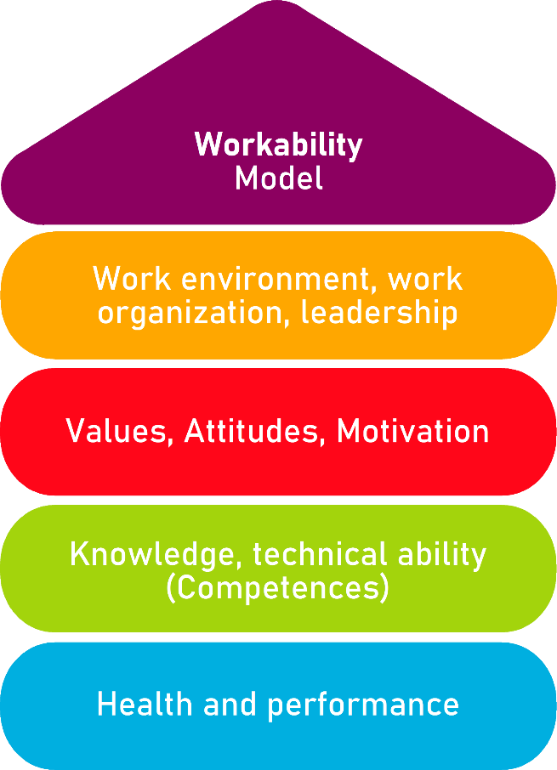

**Tool 13 A**

**Designing Work Sessions Well – Designing change management processes in small companies**

**Description of the tool**

Especially in small businesses, it is important that everyone pulls together. Especially in the case of change management processes, employees often react angrily if they are not informed in good time. It is often also helpful to involve employees in important change processes right from the start. In this way, a common understanding of the necessary measures can be created. One possibility for the participation of employees is the implementation of topic-related work sessions.

The tool is of great importance to approach problem solving in the direction of company development in an employee-oriented manner.

**Target group**

Executives, owners and managing directors

**Benefit of the tool**

The present action guide provides information on how to conduct a well-designed working session and can be used for many different topics. You will receive specific information for the planning, preparation and implementation of a working session.

**Duration**

Depending on the topic, the number of employees involved and the intensity of the discussion, it takes between 1 and 3 hours to conduct a working session.

**How to use the tool**

Before a work session is conducted, you should consider whether a work session is suitable for this, its problem is to be solved. The following questions will help you:

When does a working session make sense?

* If you have any questions or problems...
* If something is to be done with the results afterwards...
* When there are many different opinions and ideas...
* When new ideas are sought...
* If an agreement is to be reached in a group...

When is working session not useful?

* For clearly defined tasks, where every work step is known...
* For routine tasks...
* If only one opinion is allowed...

The tool supports in all individual steps to carry out the session effectively:

1. Planning and preparation of the working session
2. Conduct of the working session
3. Moderation of a working session
4. The session:
   1. Collecting ideas
   2. Organizing the ideas
   3. Evaluating
   4. Working in groups
   5. Presenting group results
   6. Evaluating solutions
   7. Planning of measures for concrete measures
   8. Action plan

**1.Planning and preparation of the working session**

Before planning a working session, it is necessary to ask yourself what to achieve with the working session:

|  |  |
| --- | --- |
| Aim of the working session: |  |

It is also important to clarify the organizational **questions:**

|  |  |
| --- | --- |
| Participants: |  |
| Time, time frame: |  |
| Location and premises: |  |
| Required media (e.g., partition wall, pens, moderation cards) |  |

An **invitation** of the participants should be made early (verbally or in writing) so that everyone can adapt to it and all necessary persons can also participate.

2.Conducting the working session

**Moderation of a working session**

In a working session there is always a moderator. You should take on this role as owner or managing director. The task of the moderator is to formulate questions to the group, to prescribe the form of work and to bundle and structure the results. As a moderator, please make sure to treat the assistance of all employees in an appreciative and neutral manner. The moderator should not comment on the ideas.

**Presentation of the work steps and of the results in the working session**

To have all the results in the working session visible to everyone, it is important to record individual keywords on moderation cards and to attach or stick them to a large partition, wall or similar. The cards can be used more and more and can also be arranged differently which is a great advantage in contrast to the more static visualization on a sheet or on a board. Advantages of this approach are the following:

* Everyone can see what it's all about.
* Everyone can contribute their opinion and ideas.
* Connections become clearer.
* No contribution is lost.
* The common thread is preserved.

3. The working session

Typically, a working session takes place in the following steps:

1. Collecting ideas
2. Organizing the ideas
3. Evaluating
4. Working in groups
5. Presenting group results
6. Evaluating solutions
7. Planning of measures for concrete measures
8. Action plan
9. **Collecting** ideas
   * The moderator asks a work question that is best written down for everyone to see. The work question can also be a problem question (e.g., "What problems do you see in...?"). The question of work must be formulated unambiguously and comprehensibly for all.
   * Employees answer this question by writing down their thoughts on cards or pieces of paper. If possible, the number of cards should not be limited in order not to limit the number of employees.
   * Employees should label the cards in such a way that they are readable by all when they are hung on the partition wall. Only one thought should be noted per card.
   * When the employees have written down their ideas, the moderator collects all cards, reads them already and hangs them on the partition wall.
10. **Organizing the ideas**
    * The next step is to organize the cards into "units of meaning".
    * The cards are attached to the partition wall in such a way that it can be seen which cards belong together. Suitable generic terms or headings are then found for the units.
11. **Evaluating**
    * In order to decide with which idea or with which topic the group will continue to work afterwards, a point evaluation can be made.
    * All employees receive a certain number of adhesive dots (e.g., 3 points), which they are allowed to award for the individual topics. You may also give 3 points to a topic that you consider to be very important. The points are awarded as anonymously as possible - everyone awards the points for themselves. Instead of sticking points, everyone can make a corresponding number of crosses.
    * It is important that a clear question is formulated for the point evaluation, e.g.: Which topic should be discussed most urgently? Which topic is the most important for you? For which problem should a solution be found most urgently?

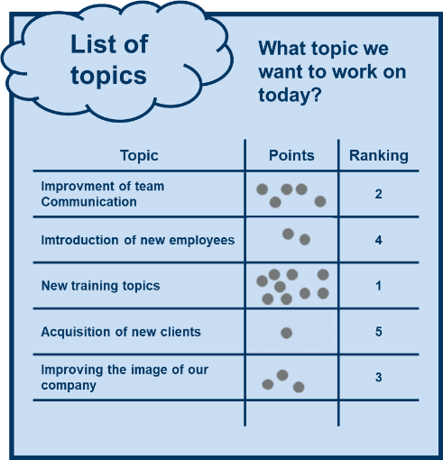

1. **Working in groups**
   * If one or more topics have been selected, they are dealt with in small groups of 3-4 employees each. With fewer than 4 employees, the topics are dealt with in the entire group.
   * The aim of the group work is to exchange opinions and collect concrete ideas.
   * If several topics are selected, they are worked on one after the other. There should be a time limit for each topic (about 20-30 min.) so that all topics can be discussed.
   * The following questions can be helpful when working on the topics:
     + What are the causes of the problem? How could these be changed?
     + What are the influencing factors?
     + What organizational possibilities are there to change something?
     + How was a similar problem solved?
2. **Presenting group results**
   * If several groups have been worked, the results of the individual groups are presented to the other employees. If there was only one group, this step is omitted.
   * It is important that the results are not commented on. Questions about understanding are of course allowed.
3. **Evaluating solutions**
   * The solutions presented by the individual groups or the entire group are now evaluated: Which ones should be implemented? Which ones would rather not?
   * Here, the entire group should make the decisions, not the moderator or the management. This is the only way to achieve a consensus among employees and to ensure a high level of acceptance for the planned measures.
4. **Planning measures for concrete action**
   * To ensure that the agreed measures are implemented, they should be set out in an action plan.
   * The action plan should also specify when and by whom the implementation of each measure is monitored.

|  |  |  |  |
| --- | --- | --- | --- |
|  | 1. **Action plan** | | |
| What?  (What action is being taken?) |  |  |  |
| For what?  (Further specification of the measure and definition of goals) |  |  |  |
| Who is responsible? |  |  |  |
| Who supports this? |  |  |  |
| In what period will the measure be implemented? |  |  |  |
| What are the costs for the realization? |  |  |  |
| Remarks |  |  |  |

Source: The tool was developed by the "AKKU" project. This project was funded by the Federal Ministry of Labour and Social Affairs (BMAS) as part of the Initiative Neue Qualität der Arbeit (INQA) and was professionally supported by the Federal Institute for Occupational Safety and Health (BAuA), Berlin. Leading project partners were: ZWH Düsseldorf, IST Wuppertal, dialogo Wuppertal, IAW (Institute of RWTH Aachen).