Regulation of the work ability in small and micro enterprises through multimedia tools

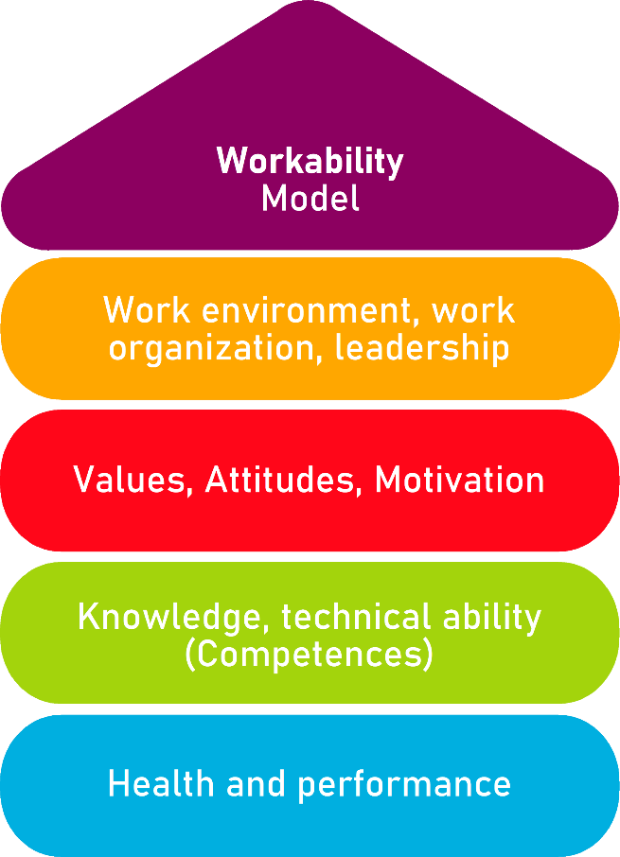

Tool 23
How to support wellbeing and health in the workplace?

Description of the aim________________________________________________________
This tool allows micro-enterprises, small business and potential entrepreneurs to support the wellbeing and health, and enhance the work participation of all employees, regardless of their current work ability and health status. Managers can recognise factors that already support employees to feel well at their workplace and what can be done in the future. It also aims to aid to prevent chronic health problems.

Target group
Employers of micro and small enterprises, human resources personnel.
Benefit of the tool____________________________________________________________
Thanks to the checklist offered, this tool allows to find new ideas to introduce in the company to improve working conditions, which can benefit both employees and employers. The future introduction of measures proposed in the tool ensures retaining full earning capacity, avoiding dependence on a disability scheme. The tool implementation results also in higher motivation, commitment and productivity of the employees and better productivity.

Duration
This tool can be developed in approximately 30 minutes.
How to use the tool
To take advantage of the tool, the manager will start by filling the checklist. It presents proven means through which workplaces can support the wellbeing and health, divided into 5 groups: (i) nutrition, (ii) physical activity,(iii) ergonomics, (iv) mental health, wellbeing and recovery from work, and (v) community spirit and atmosphere. The person who fills the checklist can decide if the proposed mean is already in use in the company, not yet in use, but potentially beneficial and feasible for the company or selected for implementation in the company. It also gives space for own ideas

Checklist for employers
Fill in this checklist about means that support well-being and health in the workplace. Then, evaluate the means possible to implement in your company and prepare action plan.
Nutrition | Already in use | Not yet in use, potentially beneficial and feasible | Selected for implementation
Staff restaurant
Improved nutritional quality of available food
Facilities for having packed lunch
Healthy options on work trips
Water taps
Healthy options first on menu
Making healthy food the default
Fruit and vegetables in generous portions
Cultivating positive attitudes
Access to dietitian

Lunch break

Subsidizing healthy options

Meal benefit

Physical activity | Already in use | Not yet in use, potentially beneficial and feasible | Selected for implementation
Physiotherapist’s visits

Access to physiotherapy

Sharing favourite movements

Shared printers and central coffee machines

Active sitting

Attractive stairwell to increase stair-use

Exercise equipment available in workplace

Workplace bikes

Walk to talk to colleagues

Scheduled exercise breaks

Active meetings a norm

Sports groups

Ergonomics | Already in use | Not yet in use, potentially beneficial and feasible | Selected for implementation
Time management training

Group-based supervision of work coaching
for employees
Ergonomic equipment

Height-adjustable desks

Monitored air quality in the workplace
Engaging employees in designing workplaces
Mental health, wellbeing and recovery from work | Already in use | Not yet in use, potentially beneficial and feasible | Selected for implementation
Psychologist's help desk

Assessment of mental health and wellbeing

Supportive, inclusive, and respectful
atmosphere
Email silence in the evenings

Flexible work arrangements

Time off

Cultural activities

Smart shift scheduling

Community spirit and atmosphere | Already in use | Not yet in use, potentially beneficial and feasible | Selected for implementation
Assessment of perceived work climate

Constructive communication culture

Relationships between employees and
superiors
Shared events

Overcome language barriers

Peer conciliators

Checklist: Action plan
What is to be done? | How (procedure)? | Cost estimation | Priority | Until when? (date) | Who is responsible?
Example: Time management training | Contact the trainer, find a day that suits every employee. | 50 EUR | ☒ high  ☐ medium  ☐ low | 17 January | HR Manager
☐ high
☐ medium
☐ low
☐ high
☐ medium
☐ low
☐ high
☐ medium
☐ low

