Regulation of the work ability in small and micro enterprises through multimedia tools

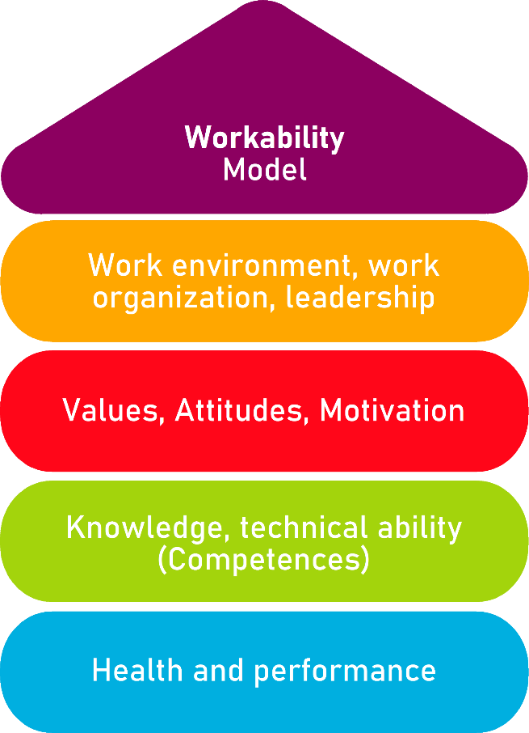

Tool 25
Assessment of employees’ health situation and ability to work

Description of the aim
This tool allows micro-enterprises, small business and potential entrepreneurs to identify employees at increased risk of long term incapacity and employees who are in need of immediate therapeutic help. It also identifies and isolates known risk factors related to the individual´s attitudes, social circumstances and health to detect known barriers to work. It is also used to get an overview of what the individual thinks is needed to improve his/her work ability

Target group
Employees and Small and Micro Enterprises Managers, HR team members.

Benefit of the tool
Thanks to the questionnaire offered, the tool allows employers to early identify the employees who may suffer from health problems due to the work conditions or other factors. It ensures that the company retains skilled staff and spares the additional costs of recruitment and training new employees. It prevents from long-term sick leaves of employees. While for employees, it results in having a sense of security and being taken care of by employers. It also ensures them that their voice is heard by superiors and their needs are not neglected.
Duration
This tool can be developed in approximately 10 minutes, but can increase if later examination of answers by managers or HR personnel is conducted.
How to use the tool
The tool consists of 14 questions (both open and close). The questionnaire should be filled in periodically especially by employees who show reduced efficiency and deteriorated quality of work. The detailed analysis of worker’s responses, conducted by manager or HR team member should indicate the problems to address and areas to improve. The problems to be solved should be elaborated in the checklist action plan.

Employee Form
Read carefully the next questions and choose the answer that adequate the most to your personal situation. In some questions, you can choose more than one option.
- How would you describe your health as whole?
Very good
Good
Okay
Poor
Very poor

- Do you have any difficulty in carrying out your work?
Yes
No

- Do you find your work physically demanding?
Yes
Not
Not applicable

- If you find your work physically demanding, in what way is it demanding? (You can choose more than one option)
Very sedentary
Standing for a long time
Changing position
Lot of walking
Having to kneel or bend over
Having to work with arms straight forward or up
Having to lift heavy objects
Having to make precise hand movement
Having to make the same movements often per minute
Having to maintain the same work position for a long time

- Do you find your work emotionally demanding?
Yes
No
Not applicable
Eye pain.
Migraines or dizziness.
Eyelids heaviness.

- If you find your work emotionally demanding, in what way is it demanding?
Keep paying attention and concentrating
Controlling my emotions
Having to memorize things
Adapting to changes
Having to work with others on a project
Having to be in direct contact with clients, customers or students
Too heavy workload
Engagement in too many projects
Too much stress related to work

- Do you think that these physical and/or emotional difficulties have any effect on your effectiveness in the workplace?
None
A little
Some
A lot
A great deal
Non applicable

- Do you suffer from any illness that influences your ability to work?
Yes
Not
Don’t know

- If you suffer from any illness that influences your ability to work,
what kind of illness is it?

- Have you discussed your illness and/or difficulties with your superior?
Yes
Not
Not applicable

- Do you feel that you need more support/assistance in your workplace to overcome the difficulties and/or be able to work despite the illness?
Yes
Not
Don’t know
Not applicable

- If you chose yes in Q11, what kind of assistance could you use?

- Do you feel that there are areas that need to be changed so that you can handle your work despite the difficulties/illness?
Yes
No
Don’t know
Not applicable

- If you chose yes in Q13, what areas need to be changed?

Checklist: Action Plan
What is to be done? | How (procedure)? | Cost estimation | Priority | Until when? (date) | Who is responsible?
Example: Reduce the numbers of project the employees take part in at the same time. |  |  | ☐ high  ☐ medium  ☐ low
☐ high
☐ medium
☐ low
☐ high
☐ medium
☐ low
☐ high
☐ medium
☐ low
☐ high
☐ medium
☐ low

