**Regulation of the work ability in small and micro enterprises through multimedia tools**

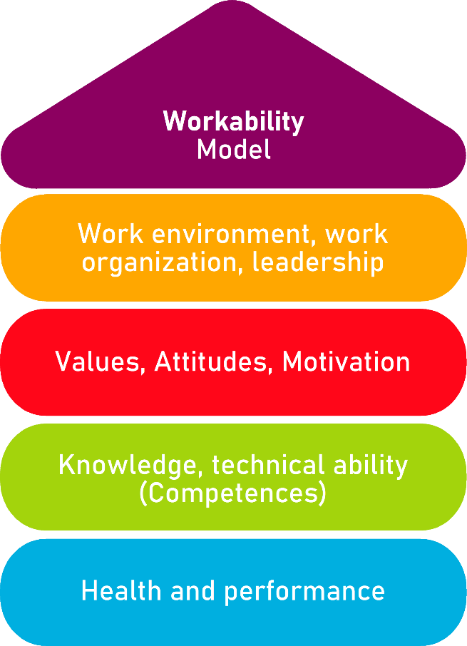

Tool 15

The ‘WAI’ questionnaire

**Description of the aim**

Developed by CIIP (Italian inter-association consultation for prevention), the [Work Ability Index (WAI) Questionnaire](https://www.ciip-consulta.it/index.php?option=com_phocadownload&view=file&id=8:questionario-wai&Itemid=609) includes a very detailed list of questions aimed at investigating among employees not only the general level of satisfaction with the work but also, and most importantly, if the tasks carried out on a daily basis in their workplace are affecting (or acted already) their well-being, physical and/or mental health.

The tool does not seem to have a specific target, meaning it can be addressed to management staff as employees. At the same time, it does not seems referring to any specific industry. External consultants as well managing directors can rely on it very efficiently and effectively.

**Target group**

Both management and employees (workers, clerks, etc.)

**Benefit of the tool**

The overall layout is very clear and easy to understand. As already mentioned, the tool can potentially find many different applications in various ecosystems since it is not tailored on any specific industry/target group. Health and well-being are universal concerns, as such, questions are designed to be as inclusive as possible. Finally, the tool is also particularly beneficial because it takes into consideration both dimensions of well-being in work places: physical and mental.

**Duration**

People in charge of the deployment of the survey are recommended to consider circa 15 minutes for each respondent.

**How to use the tool**

The tool is very self-explanatory and user-friendly. But the actual use of results can really depend on the final recipient. The tone of responses might diverge quite significantly if the targets is represented by workers (i.e. ‘blue collars’) rather than clerks. But this represents also the most interesting scenario.

For the sake of convenience let’s pretend that the management wishes to investigate the fatigue-feeling that his/her staff perceive in relation to their job and if they are truly satisfied with their conditions. Workers are typically invested in manual efforts, while generally speaking, clerks’ occupations are more ‘mental’ demanding. By comparing the two groups, management can have a very comprehensive impression on which specific function of their value chain harms staff’s well-being the most.

The model can be even further refined if the gender and generational variables are taken into consideration. This might be relevant and useful for SMEs at higher degrees of internal diversity. Results can be finally crosshatched to identify the categories at risk, and from there, design and implemented consistent safeguard plans.

If the case results depict a concerning picture, Management should consider the opportunity to conduct follow-up interviews and focus groups with representatives, groups leaders, etc.

From what we saw, there is not a defined guideline on how to use the WAI questionnaire. It is as very flexible tool that can be readapted based on the specific context of reference and the primary motivations behind its use.

In the case the WAI questionnaire is delivered by the ownership of the enterprise to both management and workers, the action plan for the implementation of the survey might be as follows:

|  |  |  |  |  |  |
| --- | --- | --- | --- | --- | --- |
| Checklist: Action plan | | | | | |
| What is to be done? | How (procedure)? | Cost estimation | Priority | Until when? (date) | Who is responsible? |
| **1.Identification of critical areas of interest** | Evaluation and assessment of the most recurrent “distress signal”. |  | high  medium  low |  |  |
| **2.1on1 consultations / focus groups with workers (or representatives)** | Isolation of specific disrupting factors for workers well-being and safety at works. |  | high  medium  low |  |  |
| **3. Adaptation and proactive responsiveness** | Recruitment of supporting staff/professionals that can be of guidance in addressing the negative outcomes (i.e., low mental well-being, widespread sense of fatigue, etc.) |  | high  medium  low |  |  |

|  |  |  |  |  |  |  |  |  |  |  |  |  |  |  |  |
| --- | --- | --- | --- | --- | --- | --- | --- | --- | --- | --- | --- | --- | --- | --- | --- |
| 1. **Type of effort required for your job:** | | | | | | | | * mainly physical work ◻️ * mainly mental work ◻️ * both ◻️ | | | | | | | |
| 1. **How would do rate your current energies compared to you peak status?**   Please, select an option from 0 to 10, where 0 = “Absolutely not in the condition to work” and 10 = “Best condition ever” | | | | | | | | | | | | | | | |
| 0  ◻️ | 1  ◻️ | 2  ◻️ | | 3  ◻️ | 4  ◻️ | | 5  ◻️ | | 6  ◻️ | | 7  ◻️ | 8  ◻️ | | 9  ◻️ | 10  ◻️ |
| 1. **Work ability in relation to the demands of your current occupation** | | | | | | | | | | | | | | | |
| How would you rate your current work ability in relation to the **physical** efforts demanded by your occupation?  Please select an option from 1 to 5, where 1 = “extremely low” and 5 = “excellent” | | | | | | | | | | | | | | | |
| 1  ◻️ | | | 2  ◻️ | | | 3  ◻️ | | | | 4  ◻️ | | | 5  ◻️ | | |
| How would you rate your current work ability in relation to the **mental** efforts demanded by your occupation?  Please select an option from 1 to 5, where 1 = “extremely low” and 5 = “excellent” | | | | | | | | | | | | | | | |
| 1  ◻️ | | | 2  ◻️ | | | 3  ◻️ | | | | 4  ◻️ | | | 5  ◻️ | | |
| 1. **Health Issues**   Please, we kindly ask You to indicate if you are suffering/suffered from any of the following health traumas/diseases | | | | | | | | | | | | | | | |
|  | | | | | | N/A | | | | Yes, but I did not consult a professional | | | Yes, a professional certified the condition | | |
| a) Musculoskeletal diseases | | | | | | ◻️ | | | | ◻️ | | | ◻️ | | |
| b) Cardiovascular diseases | | | | | | ◻️ | | | | ◻️ | | | ◻️ | | |
| c) Respiratory diseases | | | | | | ◻️ | | | | ◻️ | | | ◻️ | | |
| d) Mental disorders | | | | | | ◻️ | | | | ◻️ | | | ◻️ | | |
| e) Digestive diseases | | | | | | ◻️ | | | | ◻️ | | | ◻️ | | |
| f) Genitourinary diseases | | | | | | ◻️ | | | | ◻️ | | | ◻️ | | |
| g) Skin diseases | | | | | | ◻️ | | | | ◻️ | | | ◻️ | | |
| h) Tumors | | | | | | ◻️ | | | | ◻️ | | | ◻️ | | |
| i) Endocrine and dysmetabolic diseases | | | | | | ◻️ | | | | ◻️ | | | ◻️ | | |
| j) Blood diseases | | | | | | ◻️ | | | | ◻️ | | | ◻️ | | |
| k) Deficit at birth | | | | | | ◻️ | | | | ◻️ | | | ◻️ | | |
| l) Others. Please, specify (not mandatory): ________ | | | | | | ◻️ | | | | ◻️ | | | ◻️ | | |
| 1. **Self-estimation of workability in relation to Your health conditions**   Please, indicate how would you rate your effectiveness at work in relation to your health status. You are allowed to pick more than one option:  a) I have no health diseases hindering my job ◻️  b) I am able to carry out my job, but at times I feel very fatigued ◻️  c) At times, I feel the need to slow down and change my current task with something less demanding ◻️  d) Very frequently, I feel the need to slow down and change my current task with something less demanding ◻️  e) Due to my health condition, I can only perform part-time job ◻️  f) I feel like I cannot participate anymore the labour marker ◻️ | | | | | | | | | | | | | | | |
| 1. **Sick leave rate in the last 12 months**   a) none ◻️  b) less than 10 days ◻️  c) between 10 and 24 days ◻️  d) between 25 and 99 days ◻️  e) between 100 and 365 days ◻️ | | | | | | | | | | | | | | | |
| 1. **Based on your own evaluation, will you be able to carry out your work throughout the next two years?**   a) Unlikely ◻️  b) Likely ◻️  c) I do not know ◻️ | | | | | | | | | | | | | | | |
| 1. **Personal Resources**   Based on your own impressions, how would you rate your work life balance?  Please indicate an answer from 0 to 4, where 0 = “very poor” and 4 = “excellent” | | | | | | | | | | | | | | | |
| 0  ◻️ | | | 1  ◻️ | | | 2  ◻️ | | | | 3  ◻️ | | | 4  ◻️ | | |
| Based on your own impression, how would you rate your recent mood?  Please indicate an answer from 0 to 4, where 0 = “very poor” and 4 = “excellent” | | | | | | | | | | | | | | | |
| 0  ◻️ | | | 1  ◻️ | | | 2  ◻️ | | | | 3  ◻️ | | | 4  ◻️ | | |
| Based on your own impression, how would you rate your expectations for the future?  Please indicate an answer from 0 to 4, where 0 = “very poor” and 4 = “excellent” | | | | | | | | | | | | | | | |
| 0  ◻️ | | | 1  ◻️ | | | 2  ◻️ | | | | 3  ◻️ | | | 4  ◻️ | | |

**How to interpret data**

The first seven subjects are addressed by one or more questions. The WAI value is calculated by adding manually the points achieved in each dimension as indicated below[1]:

|  |  |  |
| --- | --- | --- |
| WAI Dimensions | Number of questions | Distribution of points of the answers |
| Current working capacity compared to the best working capacity ever achieved | 1 | 0-10 points (take the checked value from questionnaire) |
| Workability in relation to the requirements of the work activity | 2 | Weighting of points according to the work requirement (see below for calculation formula) |
| Number of current diseases diagnosed by the doctor | *Short version*: 1 list of 12 disease groups | 0 Diseases 7 points  1 Illness 5 points  2 Diseases 3 points  3 Diseases 3 points  4 Diseases 1 point  5+ diseases 1 point |
| Estimated impairment of the work management by the diseases | 1 | 1-6 points (value of replies ticked in the questionnaire; in the case of several answers, the lowest value is counted) |
| Sick leave days in the past 12 months | 1 | 1-5 points (value of the answer ticked in the questionnaire) |
| Assessment of one’s own workability in 2 years | 1 | 1, 4 or 7 points (value of the answer ticked in the questionnaire) |
| Psychological performance reserves | 3 | The values of the ticked answers to the three questions are added together. The sum results in the following distribution of points:  Sum 0-3 1 point  Total 4-6 2 points  Total 7-9 3 points  Total 10-12 4 points |

Concerning the “workability in relation to the requirements of the work activity”, the workability is recorded with regard to the physical and psychological demands of work. The answers to this question is weighted according to the extent to which the respondent’s usual activity is predominantly physical or predominantly mental. Either this aspect is evident from the selection of the groups of people to be interviewed or it must be inquired in advance in the WAI questionnaire.

* For employees with predominantly physical work (i.e., assembly work, cleaning), the value of the first question in dimension 2 (ability to work in relation to physical requirements) is multiplied by 1.5.

On the other hand, the value for the second question (ability to work in relation to psychic requirements) is multiplied by 0.5. Both calculated values are then added together. (example: first question 3 points and second question 5 points: [3 x 1.5] + [5 x 0.5] = 4.5 + 2.5 = 7

* For employees with predominantly intellectual activity (i.e., office work, teaching, administration), the reverse applies: the value of the first question (ability to work in relation to physical requirements) is multiplied by 0.5. The value for the second question (ability to work in relation to psychological requirements), on the other hand, is multiplied by 1.5. (example: first question 3 points and second question 5 Points: [3 x 0.5] + [5 x 1.5] = 1.5 + 7.5 = 9

Persons who are equally mentally and physically active (i.e., nursing professions, drivers, even physically active night workers are included) the unchanged values of the two questions are added. (example: first question 3 points and second question 5 points: 3 + 5 = 8

***TOTAL:***

The highest achievable score in the index is 49 (maximum working ability), the lowest is 7 (minimum ability to work). All questions in the questionnaire must be answered so that the index can be calculated. Half points in the overall result are rounded up to the next whole value (i.e., 28.5 to 29 points).

1. INQA WAI Network Germany, based on the version implementedin Germany in 1998