Regulation of work ability in small and micro enterprises through multimedia tools

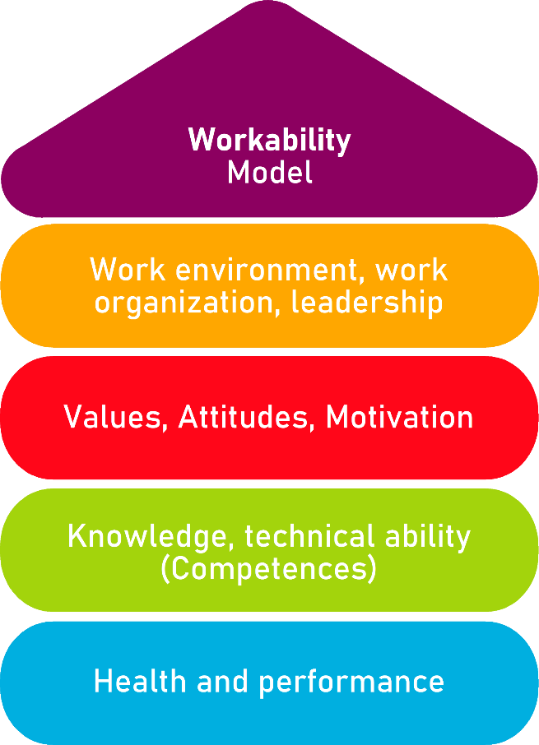

Tool 27A/B/C
Remote work: Do our workspaces fit our needs?

Description of the aim
Due to the pandemic, many businesses have implemented remote working, as a result, workers had to turn their homes into offices. Despite the resulting compromise to allocate home space for said ‘home offices’, it does not always meet the right security measures. This tool enables an analysis of home working stations to understand whether the adopted measures and habits are adequate, if they were not, advice and recommendations on how to improve them will be provided.
Target group
Administration and workers
Benefit of the tool
This tool allows the worker to understand if his/her station is well adapted or whether it needs changes in order to boost his/her working activity, at the same time, this tool is also useful for their enterprises, since it will let them know the current state of their workers.
Duration
In order to carry out this activity, 20 minutes will be needed.
How to use the tool
This tool is presented in the shape of a yes/no survey to be filled by both workers and businesses. Affirmative answers would mean that the measures adopted by workers are correct and no changes should be made, on the other hand, negative answers, would entail reading the recommendations in the last column in order to know what are the measures to take on health, work and effectiveness grounds. Lastly, a checklist will be provided to verify that your home work station takes into account the necessary conditions to work efficiently.

Characteristics of the workspace | Yes | No | Suggestions
Do you work with a computer? Does it have all you need? (i.e. necessary hardware and software specifications and peripherals in order to carry out your job). |  |  | If you do not have the necessary tools, we advise you to find a reconciled solution with your enterprise.
Do you have a stable Internet connection at home that lets you work without issues? |  |  | In case of a negative answer, it is advisable to find a safe and stable internet provider or to request assistance from your enterprise.
Does your screen allow you to see characters properly? |  |  | If you cannot, it is possible to change the character size and adapt it to fit your needs.
Is it possible to adapt your screen contrast and brightness? |  |  | Computers have a menu with the screen settings so features like brightness and contrast can be tuned to meet the user needs.
Can you change the tilt angle of your screen? |  |  | If your current screen tilt angle does not allow for comfortable work, try adjusting it or using an adapter to do so.
Does your working surface have enough room to rest your hands or forearms while using the keyboard? |  |  | If you do not have enough space, keyboard position can be changed to ease forearm and hand rest.
Do you manage to put all you need on your table/desk? (i.e. the computer and all working materials needed to carry out your job). |  |  | Placing said materials in a way it does not affect neither your posture nor comfort is recommended.
Is there enough space below your work desk to enable posture shifts and leg movement? |  |  | Leaving as much as possible space below the desk is advisable to foster posture shifts.
Does your chair allow you to adopt a comfortable position, adjusting its back and height? |  |  | These features are necessary to keep a correct posture during working hours.
Does the place you work at help you focus? is it quiet? |  |  | In case of a negative answer, finding another place at home to improve your focus and calm is advisable.
Is your work station sufficiently lit? Are there both a natural and an artificial light source? |  |  | It is recommended to work in a well-illuminated area so it does not affect workers’ sight, complementing both natural and artificial light sources would be optimal. In case it was not possible an artificial light source should be used.

Please see below a checklist with some of the aspects needed to be considered so your “home office” has the adequate conditions so your working activity can be carried out in an effective way. If you do not have the elements mentioned here, you may contact your enterprise to request the necessary assistance and resources.
Checklist | Yes | No
If you work from a laptop, do you use an additional screen and/or keyboard?
In your ‘home office’ there is a space allocated to you, artificial and natural light and there is no noise so you can focus without interference.
There is a fire extinguisher and a first-aid kit at home.
You keep a good relation with the team, you organise weekly online meetings, you can easily reach workmates via chat or other tools and receive team support.
You can work as in office, take bathroom, snack, drink and walking breaks.

Checklist: Action Plan
What is there to do? | ¿How to do it? | Estimated cost | Priority | Deadline | Who is the responsible?
Self-evaluation of used measures | After filling the survey, the worker will analyse the measures he/she uses, taking into account both the valid and those which are not. |  | ☐ high  ☐ medium  ☐ low
Change application | After identifying wrong answers, they will read the suggestions and apply the changes suggested by the tool. |  | ☐ high  ☐ medium  ☐ low
Informing the enterprise | The enterprise will request worker’s survey answers, in order to know the current state of their work stations and help them if needed, to find the necessary measures. |  | ☐ high  ☐ medium  ☐ low

