Regulation of workability in small and micro enterprises through multimedia tools

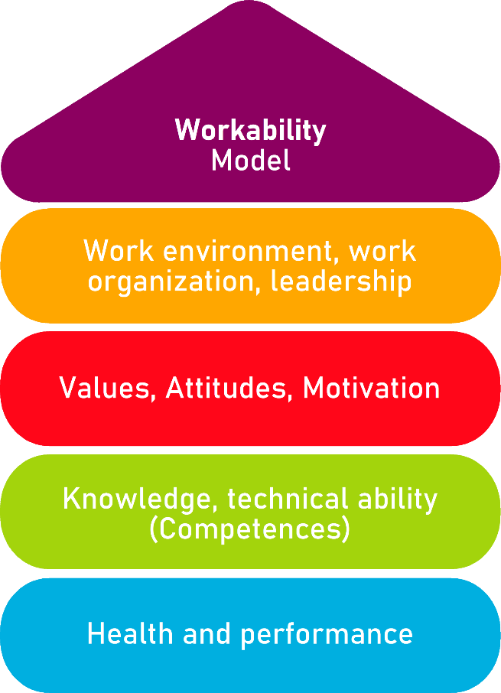

Tool 5B_2

Check Workability – Employees

Description of the tool
Maintaining the workability is an important success factor for companies. Especially due to the extended working life, it is important to maintain and promote the workability at various levels. The workability does not only mean health, but also includes other important aspects in the company such as working conditions, the lived corporate culture and the skills of the employees.
The tool is a basic analysis tool to analyze the situation of management and employees about workability. It is a tool that can be used by an external consultant to take the right measures to improve the situation.
The recommendations for action show concrete implementation steps to promote the workability or point to a deeper need for analysis. Based on the 20 questions on all floors of the House of Workability according to Prof. Ilmarinen, the tool enables an excellent assessment of the workability capacity of the management and the employees.
Tool 5B_1 is the questionnaire for the management. Tool No. 5B_2 is the questionnaire for employees.

Target group
Employees

Benefit of the tool
The Check workability enables a first introduction to the topic of workability and provides initial indications of the workability of employees and managers in your company.
By using this online analysis tool, a very structured presentation of the situation on the net is possible. All results are clearly presented in the form of a "house with the 20 rooms" on the corresponding floors. Here, the results are color-coded and displayed (green- no need for action; blue-medium-term need for action and red-urgent need for action).

Duration
The check is an analysis tool and can help to improving your company's success – 20 minutes are well invested here.

How to use the tool
The check consists of a total of 4 question areas with 5 questions each on the following topics:
- Work, organization, leadership
- Values, attidudes, motivation
- Qualification and competence, talent management
- Health and performance
After the traffic light system, please tick which statements apply to you and your company (green), which partially apply (blue) and which are rather not (red). You can directly see where there is a need for action in your company to improve the workability.
The online registration by the management takes place first (tool 5B_1_AKKU_Tool_Check workability - management). After completion, the user (manager) receives an ID number, which is passed on to the employees. With this ID number, employees can then log in to complete the check online (tool 5B_2_AKKU_Tool_Check workability - employees).
The following evaluation options are available:
- Management Evaluation
- Evaluation of all employees
- Evaluation of the entire company
- Deviations: Management to employees
An action plan helps to define the activities and measures that need to be tackled.

Organisation of work | Applies  (no need for action) | Partially true  (partly required for action) | Rather not true  (concrete need for action)
1. Age structure  The age structure in our company is balanced and there are no particular challenges in this regard. |  |  | 
2. Work design  The activities and work processes are designed in such a way that we as employees can in principle work until the regular retirement age. |  |  | 
3. Working hours and location  Employees can arrange their working hours flexibly (part-time, working time accounts, etc.). There is the possibility to work mobile. |  |  | 
4. Structures and processes  Our processes are planned and described and regularly checked for opportunities for improvement. |  |  | 
5. Transparency and competence  In our company, everyone knows what is expected and who has which decision-making powers. |  |  | 

Values and settings | Applies  (no need for action) | Partially true  (partly required for action) | Rather not true  (concrete need for action)
6. Leadership and motivation  Through its leadership behavior, the management contributes to the motivation and identification of employees with the company. |  |  | 
7. Employer attractiveness  The company has a good image in the region and in our industry and is perceived as an attractive employer. |  |  | 
8. Working atmosphere  Overall, the working atmosphere in the company is very good. |  |  | 
9. Identification with the company  Employees of all areas of work and age groups identify with the company. |  |  | 
10. Participation  Workability are involved in work planning and design. |  |  | 

Qualification and competence | Applies  (no need for action) | Partially true  (partly required for action) | Rather not true  (concrete need for action)
11. Young talent and specialists  It is currently and certainly well in the future to attract junior staff (trainees) and experienced specialists to our company. |  |  | 
12. Employee skills  The management is aware of the strengths and weaknesses of the employees and the employees are deployed accordingly. |  |  | 
13. Personnel development  Based on the constantly changing requirements, existing knowledge and qualifications in the company are systematically further developed. |  |  | 
14. Continuing education  Through appropriate qualification offers, we as employees are always up to date with the latest knowledge. |  |  | 
15. Knowledge retention  The management ensures that even when employees leave, their competencies are retained by the company. |  |  | 

Safety and health | Applies  (no need for action) | Partially true  (partly required for action) | Rather not true  (concrete need for action)
16. Occupational health and safety  The company has binding regulations and instructions regarding occupational safety and health protection. |  |  | 
17. Risk assessment  A risk assessment (including psychological stress) has been carried out and corresponding risks in the company have been identified. |  |  | 
18. Occupational safety  The maintenance (inspection, servicing and repair) of buildings, plants and work equipment in the company is regulated. |  |  | 
19. Health situation  In our company, health problems of the employees occur rather rarely. |  |  | 
20. Health promotion  The management has taken measures to avoid stress and illness and to support our health. |  |  | 

Evaluation

Workability

Work organization | 1.  Age structure | 2.  Work design | 3.  Working hours and location | 4.  Structures and processes | 5.  Transparency and competence
Values and settings | 6.  Leadership and motivation | 7.  Employer attractiveness | 8.  Work atmosphere | 9.  Identification with the company | 10.  Participation
Qualification and competence | 11.  Young talent and specialists | 12.  Employee’s skills | 13.  Personnel development | 14.  Continuing education | 15.  Knowledge retention
Health and performance | 16.  Occupational health and safety | 17.  Risk assessment | 18.  Occupational safety | 19.  Health situation | 20.  Health promotion

Action plan
What?
(What action is being taken?)
For what?
(Further specification of the measure and definition of goals)
Who is responsible?

Who supports?

In what period will the measure be implemented?

What are the costs for the realization?
Remarks

Source: The tool was developed within the project "AKKU". This project was funded by the Federal Ministry of Labour and Social Affairs (BMAS) as part of the Initiative Neue Qualität der Arbeit (INQA) and was professionally supported by the Federal Institute for Occupational Safety and Health (BAuA), Berlin. Leading project partners were: ZWH Düsseldorf, IST Wuppertal, d-ialogo Wuppertal, IAW (Institute of RWTH Aachen).

