Regulation of the work ability in small and micro enterprises through multimedia tools

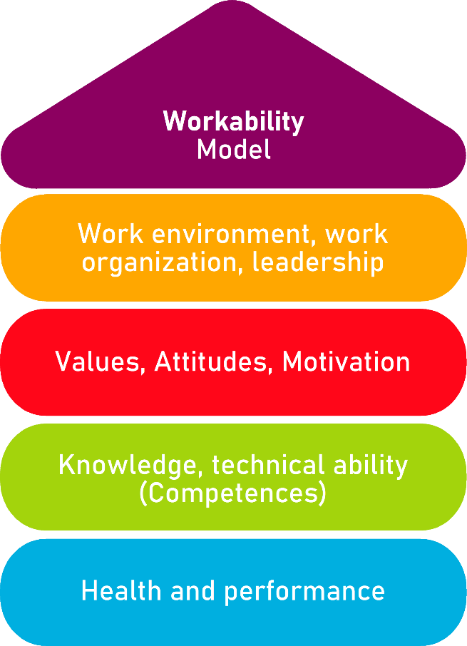

Tool 29

Business Development Plan

Description of the aim
This tool allows potential entrepreneurs to recognise their qualities and exploit them thanks to a business plan. Before we start an enterprise, we must think of ourselves. Recognising our strengths and weaknesses, seeking inspiration from other entrepreneurs or setting goals, obstacles or scenarios will help us understand the dynamics and possible situations in which we may find ourselves once we start our business. This form will allow you to analyse all these aspects succinctly and effectively.
Target group
Small and micro-business, entrepreneurs.
Benefit of the tool
Thanks to the guidelines offered by this tool, it is possible to understand our entrepreneur features, both those we must boost and those we must correct. Thinking of our references and objectives is necessary to implement our business plan, and to know how to react in every commercial situation. Anticipation is a must in our entrepreneurial journey, and a good action plan of our business can make the difference.
Duration
The next tool offers a series of forms and charts to fill in with our business plan. The duration of the tool can vary from 30 minutes to 2 hours, as there are sections that may need research. Nevertheless, these sections can be modified and updated during our company development. Therefore, the duration of the course is up to the user information and needs.
How to use the tool
The next form is arranged in 5 sections:
- Entrepreneur features form.
- References form.
- Scenarios form.
- Objectives form.
- Action plan.

The entrepreneur must read the indications in each section and reflect about each field in the chart. After this, the chart must be filled with the required information, so that it can be consulted, updated and shared with our team.

Tool 29
Business Development Plan

The beginning of our professional development begins with us. This is why it is necessary to know ourselves, our strengths and weaknesses, our goals and interests. Only if we achieve this, we will understand how to improve our features to start our company. You can fill in the following form to learn how to exploit all your possibilities.

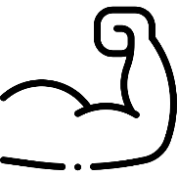
Strengths
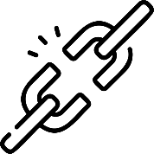
Weaknesses
Interests

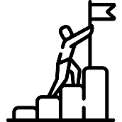
Objectivess

Other key aspects when taking our first steps into the entrepreneurship journey are references. These are close, known, famous or historic people that serve as precedents and inspiration for our projects. Understanding their work, techniques, methods or tips may help us to learn and implement our ideas. In this chart, you can fill in the following sections to understand your references and let them help you in your entrepreneurship process.

Name
Ocupation

Key aspects of their success
Elements to implement

Name
Ocupation
Key aspects of their success
Elements to implement

Name
Ocupation
Key aspects of their success
Elements to implement

Once we start a project, we must consider different possibilities. The scenarios we might encounter are diverse, but we must be prepared for both favourable and unfavourable ones. This is why anticipation and preparation are key for knowing how to react in any case. You can fill in the following chart so you can design your plan depending on the scenario.

Scenario 1: Favourable
Characteristics
Objectives
Obstacles

Scenario 2: Neutral
Characteristics
Objectives
Obstacles

Scenario 3: Desfavourable
Characteristics
Objectives
Obstacles

Other aspects to bear in mind are our goals and objectives. Every entrepreneurship Project has goals to achieve, and thus, steps to follow. We must begin with the closest and most achievable objectives, and scale our list until we achieve our goals. In the next section you can write and plan them.

Objectives
Necessary elements

Plan to follow
Estimated time
Objectives
Necessary elements
Plan to follow
Estimated time

Objectives
Necessary elements
Plan to follow
Estimated time
Objectives
Necessary elements
Plan to follow
Estimated time

Action Plan
What is to be done?
Which are the steps to follow?
What do I need to do it?
What is the estimated deadline?
What is the budget?
Who is involved?

