Regulation of workability in small and micro enterprises through multimedia tools

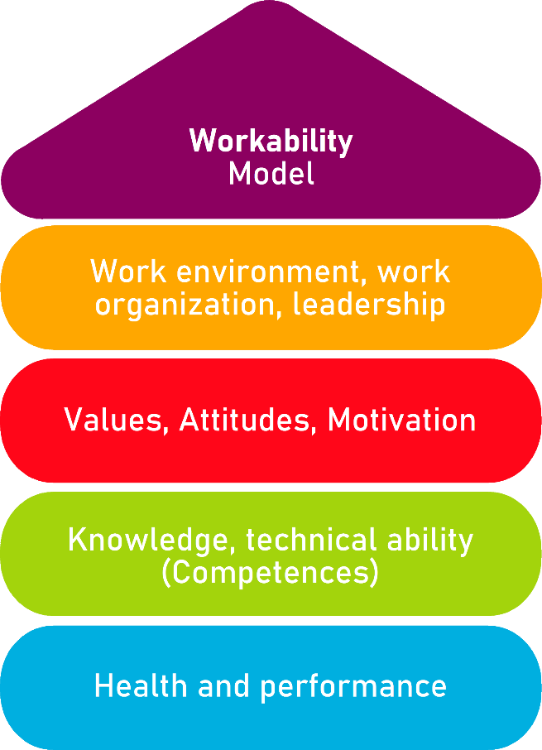

Tool 9

Check Office Workplace

Description of the tool
In many cases, working at a desk and on the screen is associated with special and sometimes very high loads, which can be avoided by a good design of the workplaces. As a result, the long-term maintenance of the workability can be supported by usually only small changes.
The aim of this instrument is to improve office activities in such a way that employees can carry out their work in a healthy and unrestricted manner until retirement.

Target group
- Executives, owners and managing directors
- Employees

Benefit of the tool
With the Check Office Workplace, you can specifically check the quality of the workplace in your office. Please check each individual workplace, as the conditions will always differ. The Check Office Workplace can serve as an introduction to a comprehensive risk assessment.

Duration
The processing of the Check Office Workplace takes about 20 minutes. Please discuss the necessary measures with the management or with your employees.

How to use the tool
After you have described the workplace in a first step, please tick whether your workplace is optimal in the points mentioned ("yes") or not ("no").
If possible, make small changes directly and then evaluate your workplace after the change. If necessary, please explain your assessment in the column "Remarks" to be able to refer to it when developing design measures.

The Check Office Workplace covers the following areas:
1.Job description
2.Arrangement of work equipment in the room
3.Lighting and lighting conditions
4.Indoor climate and noise
5.Worktable, work surface
6.Arrangement of work equipment
7.Office work chairs
8.Emergency care
9.Ladders and steps
10.Miscellaneous

1. Job description
Name of the company:
Workplace of: (name of the employee)
Description/ comments (room, equipment etc.):

2. Arrangement of work equipment in the room
Optimal workplace? | Possible measures to improve | Workplace optimal? | Remarks
The workstation or the screen is positioned parallel to the window with a viewing direction. | - Set up the workstation or screen accordingly. |  Yes   No
The free movement area at the workplace is at least 1.50m2. | - Change the workplace so that the unobstructed free movement area is at least 1.50m2. |  Yes   No
The depth of the user area at the workplace is at least 1.00m. (m = meter). | - Redesign the workplace. |  Yes   No
Passageways are sufficiently wide.  - up to 5 users: 0,88m  - up to 20 users: 1,00m | - Design the workspace in such a way that the passageways are sufficiently large. |  Yes   No
The floor is safe to walk on. | - Remove tripping points.  - Repair floor. |  Yes   No

3. Lighting and lighting conditions
Optimal workplace? | Possible measures to improve | Workplace optimal? | Remarks
There is no glare from luminaires or bright surfaces. On the screen surface, reflections – for example from lamps, windows – are not disturbing. | - Redesign the workplace accordingly, if possible. |  Yes   No
The illuminances (average 500 lux) are sufficient. | - Use lighting.  - Open the sun protection device when it is no longer needed.  - Indicate defective lamps. |  Yes   No
Suitable adjustable sun protection devices are available to help avoid glare and reflections. | - Use the existing equipment (e.g., blinds, partitions) accordingly. |  Yes   No

4. Indoor climate and noise
Optimal workplace? | Possible measures to improve | Workplace optimal? | Remarks
I am satisfied with the climatic conditions (air temperature, drafts) in my work area. | - If you are not satisfied, please tick "No" and describe the impairments under "Remarks". |  Yes   No
My workplace is free of interference from noise. | - If this is not the case, please tick "No" and describe the impairments under "Remarks". |  Yes   No

5. Worktable, work surface
Optimal workplace? | Possible measures to improve | Workplace optimal? | Remarks
The size of the work surface (table surface) is at least 1.60m x 0.80m or 1.28m^{2.} When using additional work equipment, a larger work surface may be necessary. | - Expand the work surface and/or create free work surfaces (e.g., use storage areas in shelves/cabinets).  - If necessary, talk to the management. |  Yes   No
The height of the worktable is 0.74m (± 0.02m) or a height-adjustable table is set correctly. | - ACTUAL height= ___cm  - TARGET height = ___cm  - The upper arms hang loosely down and the forearms form a horizontal line to the keyboard.  - Upper and lower arms form an angle of 90° or more. |  Yes   No
Sufficient leg and foot space is available:  The legroom for a seat workplace is at least 0.85 m. | - Remove constricted items – for example: computer, printer, waste paper. |  Yes   No
Seating and standing workstations are adjustable in height at least between 0.65m and 1.25m. | - Redesign or renew the workplace, if possible. |  Yes   No
At standing workstations, the footwell is at least 790 mm wide, 150 mm deep and 120 mm high. | - Redesign or renew the workplace, if possible. |  Yes   No

6. Arrangement of work equipment
Optimal workplace? | Possible measures to improve | Workplace optimal? | Remarks
Where templates are often used, template holders are used that are sufficiently large, stable and adjustable in inclination between 15 and 75 degrees. | - Insert template holder. |  Yes   No
Frequently used work equipment (e.g., the screen) are centrally located in the field of vision so that uncomfortable head and body postures are avoided as much as possible. | - Arrange the screen centrally.  - Place the screen directly on the worktable (not on the computer or other objects).  - Check the visual distance to the screen. |  Yes   No
The distance between the user's eyes and the screen, keyboard and template is largely the same and is at least 0.50m. | - Check the visual distance to the screen.  - Arrange the workplace accordingly. |  Yes   No
The top line on the screen is at eye level or lower. | - Lower the screen.  - Do not use swivel arms or stands.  - Remove the screen from the computer or other bodies. |  Yes   No
The keyboard is separated from the screen and can be variably positioned. In front of the keyboard there is enough space (at least 0.10m to 0.15m) to put on your hands. | - Consider space for the hand rest in front of the keyboard.  - If necessary, connect a longer cable. |  Yes   No

7. Office work chairs
Optimal workplace? | Possible measures to improve | Workplace optimal? | Remarks
The office chair is stable, e.g. it has a base with five support points (castors). | - Do not replace a stable office work chair. |  Yes   No
Unintentional pushing away or rolling away of the office chair is not possible. | - Use castors according to the floor covering: for carpet hard castors (monochrome), for smooth, hard floors soft castors (two-tone). |  Yes   No
Are you sitting right? The chair is adjusted so that the seat is at knee height and upper and lower legs form an angle of 90° or more. | - Adjust the chair correctly. |  Yes   No
The shape and adjustment options of the work chair enable an ergonomic sitting posture (feet on the floor, straight sitting posture, etc.). | - Where necessary (e.g., if your feet are hanging in the air), footrests should be used as a balance between seat height and floor. |  Yes   No
The backrest is tiltable and supports the back well in the different sitting postures, especially in the lumbar area. It reaches up to the shoulder blades or is height adjustable. | - Adjust the contact pressure and height of the backrest to your body weight and height. |  Yes   No
The office work chair is set up appropriately for the respective user. | - Individual adaptation of the chair to the user. |  Yes   No
A briefing on the operation of the office work chair has been given. | - Individual instruction of the user.  - If necessary, talk to the manager. |  Yes   No

8. Emergency care
Optimal workplace? | Possible measures to improve | Workplace optimal? | Remarks
The necessary first aid measures have been implemented. | - Provide first aid material.  - Make markings. |  Yes   No
The necessary fire protection measures have been implemented. | - Check the sufficient number and suitability of the extinguishing agents (fire extinguishers).  - Meet the test deadlines of the fire extinguishers.  - Create free access to the extinguishing agents.  - Marking of extinguishing agents.  - Do not adjust escape routes and doors. |  Yes   No
The employees are instructed in the handling of the fire extinguishers, on how to behave in the event of a fire and how to provide first aid. | - Provide instruction using templates. |  Yes   No

9. Ladders and steps
Optimal workplace? | Possible measures to improve | Workplace optimal? | Remarks
From a storage height of more than 1.80m, suitable ladders and steps are available. | - Only marked ladders and steps (EU norms) are used.  - The ladders and steps are regularly checked by a qualified person.  - The employees are instructed in handling. |  Yes   No

10. Miscellaneous
Optimal workplace? | Possible measures to improve | Workplace optimal? | Remarks
The passageways are free of fall and tripping hazards (e.g., electrical cables, file folders, bags, etc. on the floor). | - Remove appropriate objects as far as possible so that the floor is safely accessible. |  Yes   No
The electrical equipment is free of obvious defects (e.g., defective plugs, extension and device connection cables). | - If necessary, talk to an external electrician. |  Yes   No

Action plan:
Please list the points in which you answered no. Determine the importance of the individual measures (priority) and determine the concrete need for action in the planned action plan: What do you have to do to optimally design the office workplace?

Action plan
What?
(What action is being taken?)
For what?
(Further specification of the measure and definition of goals)
Who is responsible?

Who supports?

In what period will the measure be implemented?

What are the costs for the realization?
Remarks

Source: The tool was developed within the project "AKKU". This project was funded by the Federal Ministry of Labour and Social Affairs (BMAS) as part of the Initiative Neue Qualität der Arbeit (INQA) and was professionally supported by the Federal Institute for Occupational Safety and Health (BAuA), Berlin. Leading project partners were: ZWH Düsseldorf, IST Wuppertal, d-ialogo Wuppertal, IAW (Institute of RWTH Aachen).

