Regulation of workability in small and micro enterprises through multimedia tools

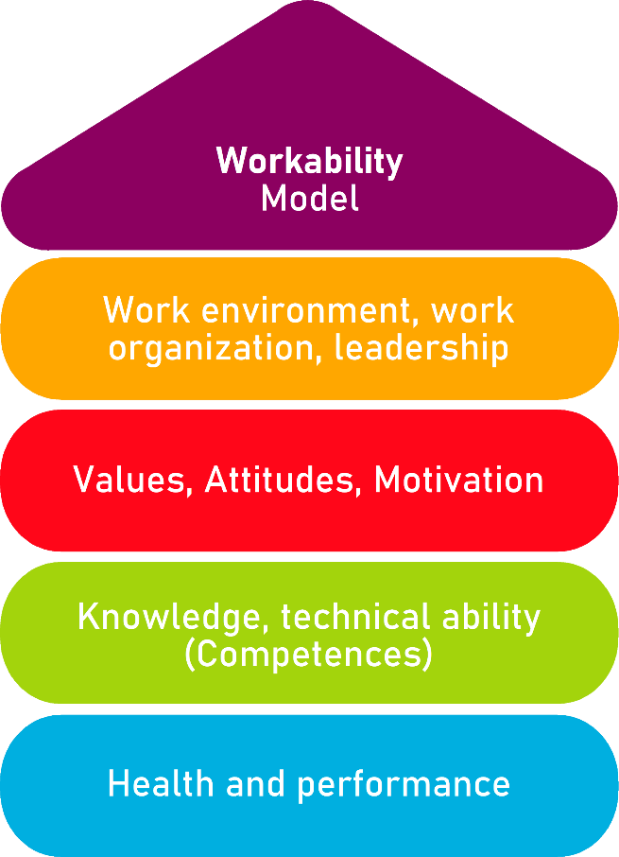

Tool 8

Ensuring learning success - Applying new knowledge in everyday working life

Description of the tool
Continuous training is important to keep employees and managers up to date and to develop skills. Especially in seminars and workshops, it is necessary to prepare the seminar visit well and to transfer and apply what you have learned to everyday work. The entire company or certain departments and their employees can benefit if one of the employees learns something new.

Target group
- Executives, owners and managing directors
- Employees

Benefit of the tool
By using the available tool, employees are supported in implementing what they have learned in further training measures on the job. Through appreciation and support in the implementation of what they have learned, employees are motivated to derive the greatest possible benefit from further training measures.
The instrument helps to:
- choosing the right training
- to have a structured preparatory discussion with the employees about the objectives and contents of the training
- define the framework conditions concretely (costs, communication, disruptions, etc.)
to have a feedback talk after completing the course (what was learned, how was the knowledge imparted, criticism, etc.)

Duration
Take at least 30 minutes to select a suitable training measure (Checklist 1: Selection of a further training measure).
In a preparatory interview, you can make all necessary preliminary discussions together with the employees in about 20 minutes (Checklist 2: Preparatory interview for participation in a further training measure).
After completing the training, please take at least about 20 minutes to exchange information about the results and record essential points (Checklist 3: Interview after participating in a further training measure).
Finally, the action plan must be completed in order to guarantee sustainable success (Checklist 4: Action plan, 20 minutes)

How to use the tool
The tool: "Ensuring learning success" is used before and after in-company further training measures (e.g. external seminar, internal training, individual coaching, on-the-job training, etc.).
The tool consists of 4 checklists:
- Checklist 1: Selection of a further training measure
- Checklist 2: Preparatory interview for participation in a further training measure
- Checklist 3: Return interview after participation in a further training measure
- Checklist 4: Action plan
The instrument helps to:
- to choose the right training
- to have a structured preparatory discussion with the employees about the objectives and contents of the training course
- to define the framework conditions concretely (costs, communication, disruptions, etc.)
to have a feedback after completing the course (what was learned, how was learned, criticism, etc.)

Preface

Success factors for further training preparation and follow-up
- In order to select a suitable training measure, first ask the question about the goal of the measure (Checklist 1: Selection of a further training measure).

- Inform yourself about content and methods at an early stage before taking part in a training course.

- When selecting the measures, consider which methods are used.

- Conduct a preliminary interview with the employees concerned (see Checklist 2: Preparatory interview for participation in a further training measure).

- Ensure that employees are freed from day-to-day business during the training measure and are not disturbed.

- Conduct an interview with the employees who have participated in the training measure (see Checklist 3: Interview after participating in a further training measure).

- After the measure, the employee should report on the training measure to colleagues and/or to the management.

Checklist 1:
Selection of a further training measure
- Which (corporate) goals are to be achieved by visiting this measure?
- What is the content of the training measure?
- What methods are used to convey the content?
☐ | Workplace-oriented learning or training for "learning on the job" is possible.
☐ | An external seminar offer is used.
☐ | During the measure, exercise opportunities are provided.
☐ | During the measure, concrete implementation options in the workplace are discussed.
☐ | Miscellaneous, namely:

Checklist 2:
Preparatory interview for participation in a further training measure
Consider for which employees this measure is relevant and make an appointment with these employees for a preparatory interview. If several people participate in the measure, a group discussion can also be held.
- Which goals should be achieved for the participant?
- Which goals should be achieved for the company?
- Do the goals coincide?
☐ Yes
☐ No, the following deviations exist:

- Is the employee informed about the contents and methods of the training measure?
☐ Yes
☐ No, the following information is still missing:

- Clarification of the framework conditions
Who takes over the deputy?
Who takes over which work?
Who pays for the training?
Is there an overtime regulation?
Are disturbances allowed during the measure?
Do the colleagues know that the employee is taking part in a seminar?
What to do after the return (e.g. report, presentation to colleagues, joint implementation meeting)?
Arrange an interview after returning from the seminar.

Checklist 3:
Interview after participating in a further training measure
- What was learned?
- Did the content and forms of learning correspond to what had been previously agreed?
- Are there any points of criticism? If so, which ones?
- Should other employees also attend this measure?
- Should the trainer be reinstated?
- What were the most important findings?
- Which questions have remained unanswered or newly emerged?
- How are the other employees informed about the content of the seminar?
- What should be implemented and introduced in the company? How can this happen? What support is expected from superiors or colleagues?

Checklist 4: Action plan
What?
(What action is being taken?)
For what?
(Further specification of the measure and definition of goals)
Who is responsible?

Who supports?

In what period will the measure be implemented?

What are the costs for the realization?
Remarks

Source: The tool was developed within the project "AKKU". This project was funded by the Federal Ministry of Labour and Social Affairs (BMAS) as part of the Initiative Neue Qualität der Arbeit (INQA) and was professionally supported by the Federal Institute for Occupational Safety and Health (BAuA), Berlin. Leading project partners were: ZWH Düsseldorf, IST Wuppertal, d-ialogo Wuppertal, IAW (Institute of RWTH Aachen).

