Regulation of the work ability in small and micro enterprises through multimedia tools

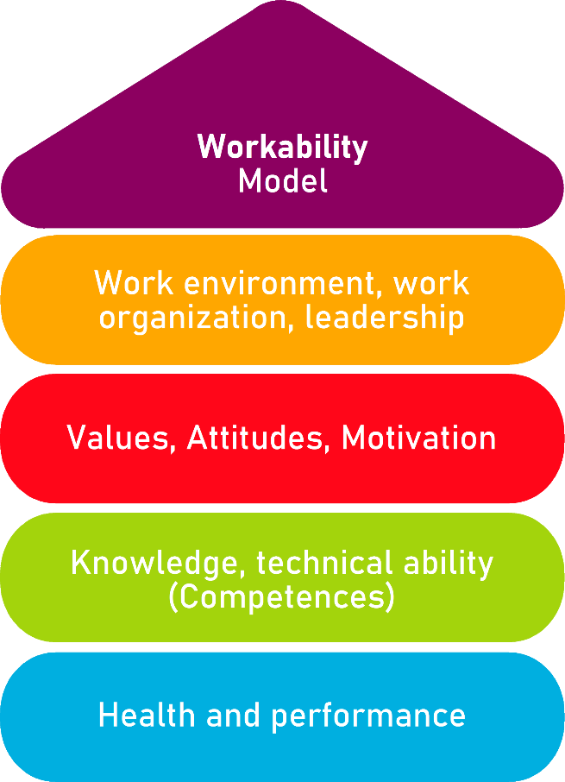

Tool 4
Onboarding – Induction of new employees

Description of the aim
This tool allows employers, managers and entrepreneurs of micro-enterprises and small business to better integrate new employees. New employees should feel comfortable from day one. Because satisfied employees are more motivated, more committed, more productive. And they stay with the company longer - which is increasingly important, especially in view of the shortage of skilled workers.

Target group
Employers, small and micro enterprise managers, entrepreneurs.

Benefit of the tool
The guide and the checklist help employers and managers of small and micro enterprises as well as entrepreneurs with the integration of new employees. The onboarding process is a tool to induct new people into the company with a clear structure so new employees can feel comfortable from the first day on.

Duration
The tool offers a guide with information what is meant by onboarding and a checklist supports the process. The approximate duration is about 20 minutes.

How to use the tool
The tool is arranged in 2 sections.
1. Onboarding guide.
2. Onboarding checklist

Read the guide carefully and use the information it offers. The checklist helps you to catch up with every step of the onboarding process.

Tool 4

Onboarding – Induction of new employees
"Welcome on board!" - every new job should start with a warm welcome. In human resource management, "onboarding" is the structured and systematic process that makes this possible. New employees should feel comfortable from day one. Because satisfied employees are more motivated, more committed, more productive. And they stay with the company longer - which is increasingly important, especially in view of the shortage of skilled workers. We explain which tools help with this, which phases successful onboarding goes through and what advantages this has...

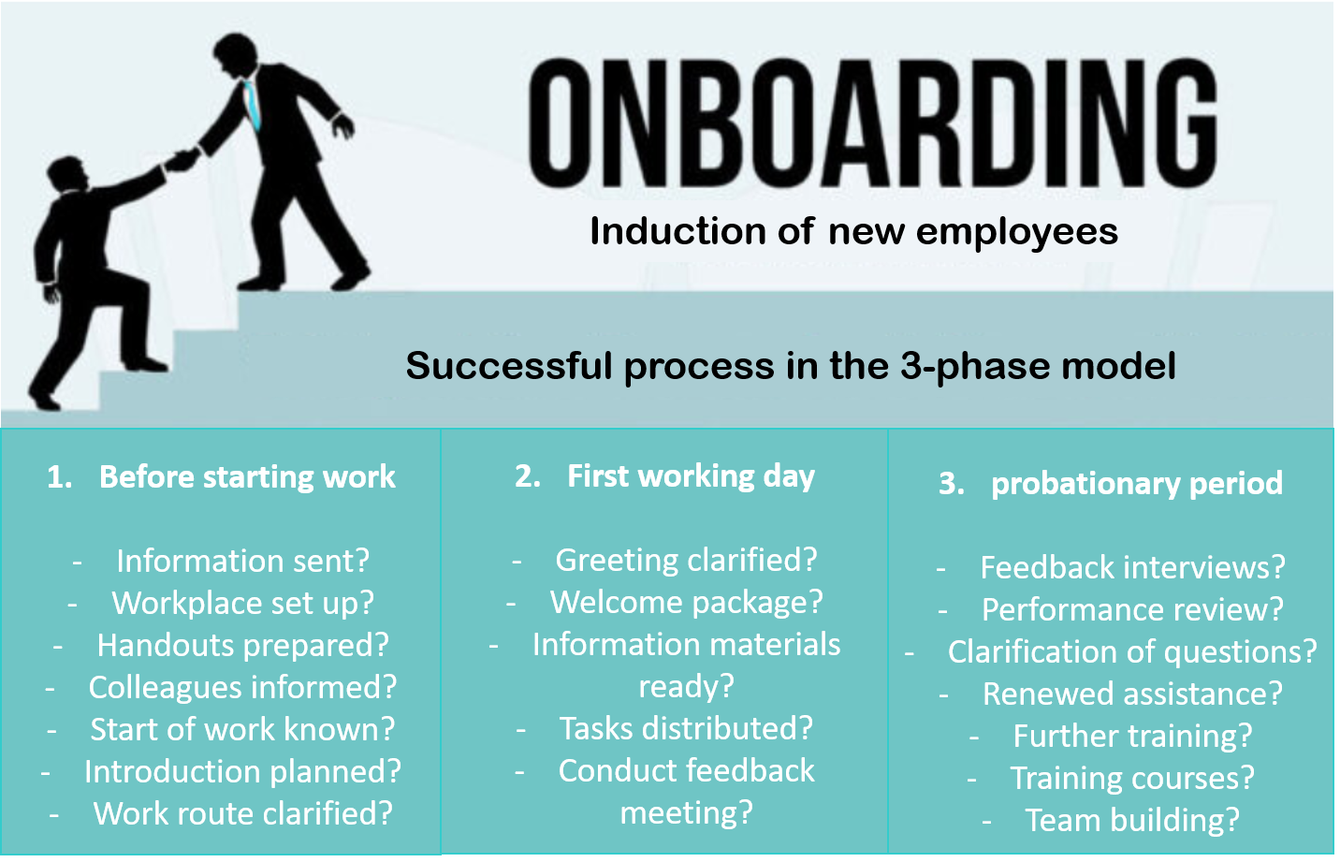
Source: www.karrierebibel.de (translated)

Definition: What does onboarding mean?
The abbreviation onboarding originally comes from the American and stands for "taking on board" - roughly translated: "bringing new employees on board". It refers to the systematic integration and familiarisation of new employees in the company. The goal is to familiarise the new employee with the company and to integrate him or her quickly into the team and the corporate culture. Good onboarding creates a feel-good atmosphere to harmonise work processes and cooperation. At the same time, this prevents the new employee from quitting during the probationary period. In short: the new employee should feel at home as a full member of the organisation from the very beginning.
Onboarding can be described synonymously as "introduction", "welcome" or "introduction". The opposite of onboarding is offboarding. This is a professional separation process - for example in the case of insolvency or major job cuts in the company.

7 advantages in the onboarding process
Good onboarding requires preparation. Properly implemented, the onboarding process offers the following benefits:

Productivity
The faster an employee is trained, integrated into processes and teams, the faster he or she can deliver top performance - and increase the productivity of the entire operation.
Motivation
Onboarding is a sign of appreciation. Employees sense and reward this - with more intrinsic motivation.
Error prevention
A single mistake can paralyse an entire operation - for example in the area of IT security. Onboarding reduces the susceptibility to errors in the early days.
Skilled labour shortage
Recruiting new staff costs time and money - especially in sectors where the supply of specialists is severely limited. It is better to bind capable people to the company at an early stage with suitable measures.

Fluctuation
To a certain extent, fluctuation makes sense - keyword: fresh wind. But if the door closes too quickly, if the personnel bloodletting is too great, painful losses of productivity and know-how are the result.
Impression
First impressions are important - for applicants, employees and companies. Onboarding measures can pave the way for a convincing first impression on all sides.
Brand ambassador
Onboarding contributes to employer branding. Those who are satisfied, perhaps even enthusiastic, will recommend their employer to others. Onboarding can therefore also help to recruit further professionals and gain customers.

Onboarding plan: the 3-phase model
The induction of new employees includes the following: Administrative and organisational formalities, the technical familiarisation with the actual work task as well as the social integration into the team and the working environment. Accordingly, a 3-phase model has been established for this. In concrete terms, this can look like this, for example:
Phase 1  preboarding | Onboarding begins before the employee starts work with phase 1, the so-called pre-boarding. This phase begins when the contract is signed and continues until the first working day (phase 2). These building blocks are important in the first phase:  Send information: Contact the newcomer BEFORE the first day of work with a nice welcome and information e-mail - possibly also by telephone. Also send him the most important information: Where he will be received by whom and when, company mission statement, organisation chart or brochures.  Obtain documents: This is where the employee's cooperation is needed. Social security card, health insurance, income tax card, tax ID: If everything is available, the first week of work will not be completely overlapped by organisational questions.  Set up the workplace: The workplace should be set up as soon as the newcomer steps over the threshold. This includes providing passwords, setting up printer access, procuring a telephone, office chair and other tools. Everything he or she needs to get started immediately.  Create a familiarisation plan: The so-called induction plan should be drawn up early - even before the employee starts work. It includes a detailed work plan for the first week; tasks; projects in which the new employee will be involved. The induction plan prevents both chaos and idle time.  Organise the flat search: A service that particularly pleases out-of-towners: companies that actively help with the search for accommodation (perhaps even with moving house and dealing with the authorities) boost their employer image enormously. Although this is also a question of costs and capacities, it can be worthwhile.
Phase 2  Welcome on the 1st working day | On the first day of work, the company leaves many first impressions. Making them positive has a strong impact on employee loyalty. The welcome phase is therefore extremely important for onboarding. Components can be:  Handing over the welcome package: A folder and keys are the basics. But private gifts also go down well: for example, a greeting card with congratulations on your first day or a bouquet of flowers.  Give business cards: Provide the new employee with business cards on his or her first day at work - even if he or she doesn't need any. Do not underestimate the effect, because: Business cards are small medals.  Prepare a reception: A tour introducing the new employee to colleagues should be the norm. Even better would be a small ceremony at the end of the working day. Dear Johannes, we welcome you warmly to our team. That way he will be happy to come back on the second day.  Having Lunch together: You quickly make contacts when you eat together or go to the canteen together.  Conduct a feedback session: A short (or longer) exchange with the supervisor (or mentor) signals that someone cares. Best combined with an initial introduction.
In the first week of work, you can lay more foundations. Examples:
Introduce safety regulations and show escape routes. Take a staff photo for the organisation chart or intranet. Show documents such as holiday applications. Hold one-on-one meetings with team leaders, department heads, IT managers and other important people. Important aspect: The new employee should get to know as many colleagues as possible in the first week of work. If he has quickly built up a network, this will strengthen the bond.
Phase 3  During the probationary period | Social integration and integration into the team cannot be achieved in one week. Therefore, onboarding accompanies the new colleague throughout the probationary period. During (and beyond) this time, these elements are important:  Organise introductions: Departments, products, projects, tasks - they can be introduced to the new employee with the help of introductory events. Another option for onboarding is to familiarise the new employee with the company through job rotation. Advantage: He or she gets to know the colleagues and departments right from the start and gains an overview of the big picture.  Offer further training: Knowledge that the new recruit will need in the future can be imparted in internal or external training and education or workshops. The prospect of professional development is also a benefit (and lure) for demanding professionals.  Conducting appraisal interviews: Especially during the probationary period, they are important to clarify open questions and wishes. How satisfied are both sides? What can the company do to support the employee even more intensively?  Forcing teambuilding: Team-building events or weekends can help to integrate a new colleague into the team. They are particularly useful in phases of personnel upheaval when overall turnover is high. Examples: Joint lunches or dinners, pub crawls or watching a football World Cup.  Keeping an external appointment: Integration should not only be successful internally, but also externally. Possibilities: joint visits to customers, conferences and trade fairs. In this way, the employer also sees his new recruit in action.  Organise excursions: Here, too, the team-building idea is at the back of your mind. Company outings and city walks can also help newcomers find their way around their new surroundings and city in a very practical way.

When does onboarding start and how long does it take?
The onboarding process starts from the moment the job is promised, but at the latest when the contract is signed. Ideally, it ends only after the probationary period in order to retain sought-after talents and specialists at an early stage and in the long term.
The duration and scope of onboarding can be weeks or even months. This depends on the complexity of the job or the tasks involved. In addition, there is the length of service of the predecessor (if any). The longer the predecessor has been with the company, the more expertise and experience he or she has accumulated. In order to pass this on, employers should appoint a contact person for queries during the induction period. Not least to take away the new employee's fears and uncertainties. In addition, supervisors can monitor the progress of the induction process and give feedback.
The sooner the employee is fully operational, productive and motivated, the better for the entire company. Ideally, after one year at the latest, he or she is integrated into the company in every respect: into the organisation, into the work processes, into the team and into the culture.

Who is involved in the onboarding process?
As a rule, at least the new employee and his or her mentor, sponsor or team leader take part in the so-called induction talks. However, it can make sense that the predecessor and other colleagues with whom the employee will later work closely also take part in the (handover) talks. In this way, all those involved can directly exchange and agree on relevant procedures, processes and projects. Ultimately, the aim is to shorten the familiarisation phase and minimise friction losses.
In a few exceptions, however, it may be advisable to exclude the new employee from discussions with his or her predecessor. Especially if this separation was involuntary. In this case, it is advisable to request the necessary information (see checklist below) from the departing employee and later pass it on to his or her successor in a filtered form through a manager.

Onboarding mistakes: The 3 worst
The induction and integration of new employees does not always go perfectly. Mistakes happen. But some of them have a demotivating, destabilising, disastrous effect. Even on the existing team. Not least because they have a signal effect - for the actual welcoming culture and appreciation of your own employees. You should therefore avoid these three onboarding mistakes at all costs:
Radio silence  The job interview was still marked by sympathy and a sense of togetherness. But now there is radio silence. Until the first day, when the employee shows up at the door. Genuine joy about a new colleague looks different. Better: contact him or her at least one week before the start of work, for example by e-mail. Less as a reminder, more as a motivational aid and a sign of enthusiasm. Tenor: "We are looking forward to seeing you! | Overload  The first working day is crammed to the brim with content and events. You are bound to get overwhelmed. Leave more space: for greetings, for small talk in the coffee kitchen or for getting to know each other in the canteen. | Infodumping  The training should be as quick as possible, all information should be passed on as quickly as possible... understandable! But it's no use showering a new colleague with information on the first day, dumping hundreds of documents, information, folders and links on him or her. Proceed systematically and do not engage in infodumping!

Checklist onboarding
Companies should treat the induction of new employees like a project. And like any good project, it requires careful planning. In this case, a so-called "induction plan". This, too, essentially comprises three phases: Preparation, first day on the job and the time afterwards (usually the probationary period). The following checklist is intended to help companies keep an overview and not forget anything.

Checklist onboarding | YES | NO
- Before starting work
Information send?
Workstation set up?
Handouts prepared?
Colleagues informed?
Start of work known?
Work route clarified?
- First working day
Greeting clarified?
Working package?
Information materials ready?
Tasks distributed?
Feedback meeting conducted?
- Probationary period
Feedback interview?
Performance review?
Clarification of questions?
Renewed assistance?
Further training?
Training courses?
Team building measures?

