Regulation of workability in small and micro enterprises through multimedia tools

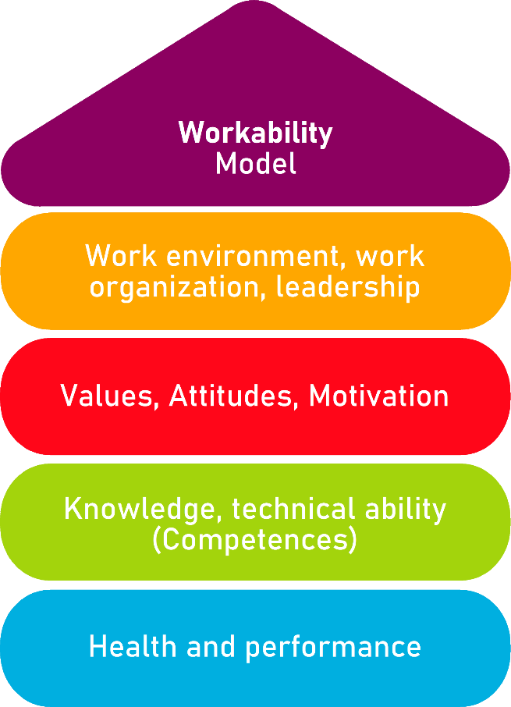

Tool 12

No stress with the stress – Stress Check

Description of the tool
It's not easy to tell if you're just a bit overworked and ready for the holiday or if the stress is making you sick. Your employees may also be exhausted due to constant stress. What about your company?
The aim of this stress check is to recognize one's own stress situation and to make the stress situation transparent with the employees.
The tool is a tool for management. It can be used without external consultants.

Target group
Executives, owners and managing directors

Benefit of the tool
The stress check allows you to reduce your own stress and recognize the stress factor of your employees and, depending on the result, to quickly take the right measures to improve the situation. The review takes 10 minutes and thus achieves clear results in the shortest possible time.

Duration
The stress check can contribute to maintaining your own health and at the same time maintaining the health of your employees – 10 minutes are well invested here.

How to use the tool
Please tick "yes" if the respective statement is correct. Please choose "yes" or "no", even if it is difficult for you.
In the first part of the stress check, you will find some typical symptoms that will give you clues as to whether your stress exposure is already leading to signs of chronic fatigue or physical illness.
In the second part, you will find corresponding statements on signs that indicate stress among employees in your company.
After processing the two parts of the check, please consider which points you would like to actively tackle in the future:
- Where do you see a need for action?
- What opportunities for improvement are there?
Please enter the necessary measures in the action plan.

Part I: How burdened am I as a manager?
yes | no
 |  | Falling asleep is no problem for me. But often I wake up in the middle of the night and still thinking of the activities of the day.
 |  | For leisure, hobbies and family, I have much less strength than before. Usually, I don't take the time for that.
 |  | I often avoid personal contact with my employees because it robs me of too much time / makes too much effort.
 |  | I have more physical complaints than before, e.g., headaches, gastrointestinal problems or tension. My doctor does not find physical causes.
 |  | I find it relatively difficult to switch off after work. Often it fails at all.
 |  | To be honest, I drink more alcohol than is good for me.
 |  | A weekend is hardly enough to relax.
 |  | Concentrated work has recently become difficult for me. Incoming e-mails or disturbances easily distract me and I find it difficult to get back to work.
 |  | If something doesn't go as I imagined in my job, I often react resignedly.
 |  | Time pressure, responsibility, inquiries – I often feel like the famous "hamster in the wheel" who always runs but never arrives.
 |  | Honestly, I have an inner resistance to my work, which I overcome every day. In everyday life, however, I function well again.
 |  | My mood fluctuates: Sometimes I don't recognize myself, for example when I react so irritably.

Part II: How burdened are my employees?
yes | no
 |  | When innovations are introduced, one hears above all grumbles – and remarks such as "That too! How are we supposed to do that?" or "Doesn't help anything!"
 |  | More often we lack information flow. Sometimes important information is passed on to colleagues late or not at all. Some tasks are therefore completed late or incorrectly.
 |  | There are often conflicts, competitive situations and quarrels among my employees.
 |  | The sick leave rate in our company is high.
 |  | I am always available for technical questions, but there is simply no time for personal discussions with employees.
 |  | With us, it is often unclear who is responsible for which task. Tasks are more often pushed back and forth.
 |  | When I meet a group of employees, I sometimes have the feeling that the conversations fall silent.
 |  | I often have the feeling that I must control the results of my employees' tasks so that they are really done properly.
 |  | Even my good employees seem more often lately as if they are not quite up to date.
 |  | It has already happened that my employees have experienced not through me, but through "corridor radio" that changes are imminent in the company.
 |  | My employees have no time for further training. The ongoing operation simply does not allow this.
 |  | Some of the employees would prefer to miss a company outing and Christmas party.

Evaluation Part I:
How burdened am I as a manager?

If you have ticked 3 or more statements, you probably have signs of overload and exhaustion due to permanent stress. Your psyche reacts irritably and defensively, your body sends signals that say: This is too much for me!

If you have ticked 5 or more statements, you probably feel yourself that the stress is growing over your head and robs you of energy, commitment and well-being.

If you've answered 7 or more statements in agreement, you've probably been claimed for several years. Your health is in danger. It is very typical for strong and performance-oriented people that they can maintain their workforce for an extremely long time and fill their job well, even if their psyche and body have long been sounding the alarm. Take responsibility for yourself and please contact your doctor to find out what role stress plays in your ailments. Find out how you can counteract the permanent strain before you become seriously ill (for example, burnout).

Evaluation Part II:
How burdened are my employees?

Each one of the above points can occur as a result of prolonged stress in a company.

However, if you had to tick 4 or more statements, you can assume that the problem does not only affect individual employees, but that there are already cross-company friction losses due to permanent stress: commitment and quality of work are falling, relationships between employees suffer.

If you found 6 or more points to be correct, your employees are probably already very exhausted. Follow-up problems occur: bullying or an extreme "service-by-regulation" mentality. Some employees may be sick more often because they have developed stress-related complaints such as back problems. Even your top performers are slowly going to their knees under the pressure.

Action plan
What?
(What action is being taken?)
For what?
(Further specification of the measure and definition of goals)
Who is responsible?

Who supports?

In what period will the measure be implemented?

What are the costs for the realization?
Remarks

Source: The tool was developed within the project "AKKU". This project was funded by the Federal Ministry of Labour and Social Affairs (BMAS) as part of the Initiative Neue Qualität der Arbeit (INQA) and was professionally supported by the Federal Institute for Occupational Safety and Health (BAuA), Berlin. Leading project partners were: ZWH Düsseldorf, IST Wuppertal, d-ialogo Wuppertal, IAW (Institute of RWTH Aachen).

