Regulation of workability in small and micro enterprises through multimedia tools

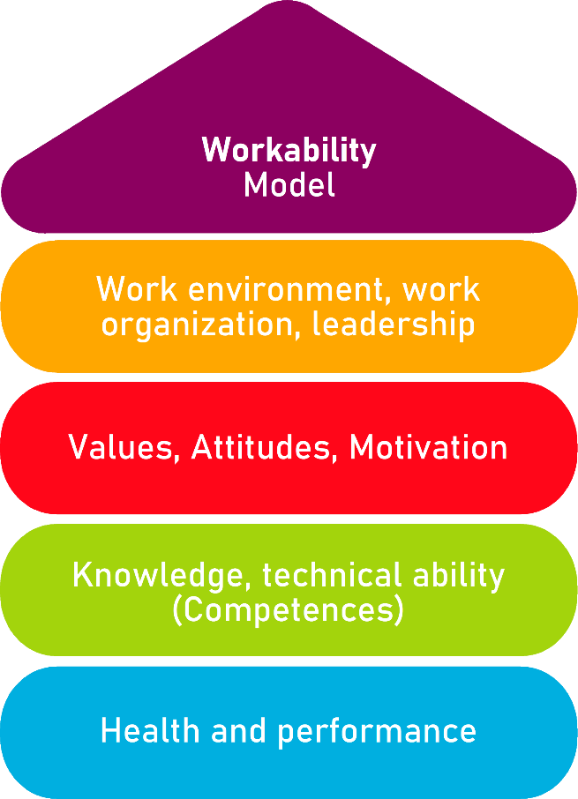

Tool 11

Check Personnel Management

Description of the tool
Good staff is indispensable for your company's success. Their success depends largely on the employees. Whether people contribute their ideas and skills to the company depends largely on the quality of your personnel management. The decisive challenges for good personnel management are: increase the attractiveness as an employee and find, promote and retain good employees.
The tool can be used by the entrepreneur himself – even without the support of an internal or external consultant.
The checklist supports the prioritization of the right and necessary need for action.

Target group
Executives, owners and managing directors

Benefit of the tool
In the Check Personnel Management you will find many suggestions for good personnel management. The check helps you to empower and motivate the employees so that good performance can be achieved.

Duration
The Check Personnel Management is an analysis tool and can contribute to the improvement of your company's success – 30 minutes are well invested here.

How to use the tool
The checklist consists of 12 parts:
- Personnel planning
- Staff development
- Personnel recruitment
- Motivating personnel measures
- Good working atmosphere
- Internal communication as a management task
- Targeted use of the diversity of different people
- Employer attractiveness
- Basic attitude of employees
- Clarifying and conveying values and principles
- Know your own strengths and weaknesses
- Plan of action

Please check according to the "traffic light system" which statements apply to you and your company (green), which are partly true (blue) and which are rather not true (red). In the action plan, define the most important measures that you want to tackle in your company. Look at all those points where you have ticked urgent need for action (red) or need for action (blue).

1. Personnel planning |  | Applies  (no need for action) | Partially true  (partial need for action) | Rather not true  (concrete need for action)
1.1 | Personnel requirements and personnel plan  I know my employees and know what they can do. I determine our (current and future) personnel requirements depending on the market and our strategy and make appropriate personnel planning.  (For example: Enter current personnel data including age, qualification, function, etc., plan future personnel requirements (Which qualifications will be required in the future? How many employees are needed for future assignments?), define personnel planning measures and discuss them with the employees) |  |  | 
1.2 | Preserving important knowledge in the company  I make sure that the existing knowledge is retained even in the event of a change or failure of individual persons in the company.  (For example: Document which employees have important knowledge, document and update knowledge about operational processes (e.g. introduce operating and operating instructions, operating instructions, etc., substitute regulations) |  |  | 
1.3 | Reintegration Planning  In the case of longer absences (e.g., parental leave, illness) of employees, I keep in touch with them. Together with the affected employees, I take care of how reintegration into the work process can take place.  (For example: discussions before and during the absence, inform about all developments in the company in the meantime, early contact for re-entry, jointly plan the measures for reintegration, observe the legal regulations on company reintegration) |  |  | 

2. Personnel development |  | Applies  (no need for action) | Partially true  (partial need for action) | Rather not true  (concrete need for action)
2.1 | Discuss development prospects with each employee  I talk to every employee once a year about their prospects in the company. I agree concrete development steps with every employee.  (For example: ask satisfaction, personal expectations and goals of the employee, give feedback on the performance and behavior of the employee, clarify personal matters – such as freedom for partners, children, relatives) |  |  | 
2.2 | Further training and quality of qualification  I take care of the implementation of further education. I check the quality and benefits of the training together with the employees.  (For example: organisation and financing of further training, querying and discussing the benefits of further training, setting learning processes in motion and promoting them in the company, e.g., through collegial exchange) |  |  | 
2.3 | Using the skills of older employees and retirees  Together with older employees, I am considering how we can use their skills in the last phase as employees or after they leave their professional lives.  (For example: Being available as a mentor for new and younger employees, carrying out work instructions, consultant in work teams, market observation and customer care) |  |  | 

3. Recruitment |  | Applies  (no need for action) | Partially true  (partial need for action) | Rather not true  (concrete need for action)
3.1 | Training  Our company provides training to secure the demand for skilled workers in the future as well.  (For example: contacts with schools and educational institutions, training cooperation with other companies, advertising among young people for career prospects in the company and occupation, retraining) |  |  | 
3.2 | Opening your eyes to new target groups  When recruiting personnel, I think about how we can also address new target groups.  (For example: career changers, long-term unemployed, people without a vocational qualification, dropouts, women for men's occupations and vice versa, older people as trainees, immigrants) |  |  | 
3.3 | Diverse recruitment channels  I think about the ways and channels we can use to attract staff and go new ways.  (For example: Employees recruit employees, social networks and training exchanges on the Internet, presentation of the Company at Schools, Universities of Applied Sciences and Universities, recruitment of foreign skilled workers) |  |  | 

4. Motivating personnel measures |  | Applies  (no need for action) | Partially true  (partial need for action) | Rather not true  (concrete need for action)
4.1 | Special working time models  I offer my employees individual working time arrangements. The working time regulations are clearly agreed with the employees in writing.  (For example: working time accounts, trust-based working hours, teleworking, part-time, working time models adapted to life phases) |  |  | 
4.2 | Special forms of remuneration  I have special forms of remuneration for special benefits and life situations. The criteria for awarding the special remuneration are well known.  (For example: profit-sharing, pension support, bonuses (performance, loyalty, anniversaries), company car, mobile phone, laptop) |  |  | 
4.3 | New employees  I ensure that new employees are trained in a structured manner and receive all the necessary work equipment and information in good time.  (For example: Clear description of the work tasks and the processes, mentor to accompany and clarify open questions, personal introduction of colleagues, welcome greeting) |  |  | 

5. Good working atmosphere |  | Applies  (no need for action) | Partially true  (partial need for action) | Rather not true  (concrete need for action)
5.1 | Using strengths – accepting boundaries – compensating for weaknesses  I know that each of our employees has specific strengths, limitations and weaknesses. I use our employees accordingly.  (For example: What do employees like to do, which employees fit which customers and which function?) |  |  | 
5.2 | Promoting team spirit  I make sure that there is a good team spirit in the company. I put together individual teams in such a way that they function well both professionally and personally – the "chemistry" must be right.  (For example: Regular team discussions, conflicts are addressed and clarified directly, community activities are organized – celebrate together, do sports) |  |  | 
5.3 | Pay attention to personal living conditions  I consider the special personal situation and the living conditions of individual employees, so that influences from the personal environment affect the work results as little as possible.  (These include, for example: working hours that allow employees a certain degree of flexibility, reintegration after illness, in special cases giving employees time off at short notice (for example, visiting the child to the doctor, caring for family members) |  |  | 

6. Internal communication as a management task |  | Applies  (no need for action) | Partially true  (partial need for action) | Rather not true  (concrete need for action)
6.1 | Techniques of good conversations and conversations  It is clear to me that in conversations my counterpart often does not understand the same as I do. I know the techniques for the success of good communication and I can implement them.  (For example: Prepare for the conversation and, if necessary, make keywords before, clear and unambiguous language, examples to clarify the statements, ask questions, let the interlocutor have his say) |  |  | 
6.2 | Creating a wide range of communication options  I promote a wide range of opportunities for employees in the company to be able to express themselves about topics that move them.  (For example: sitting areas, tea / coffee kitchen, common breaks, open door, regulars' table, "suggestion box") |  |  | 
6.3 | Regular information  I keep employees regularly informed about important developments. I am available for the questions of the employees and answer them promptly.  (For example: information/exchange about new products, projects and customers, information about business development and strategies, information about changed responsibilities, new employees) |  |  | 

7. Targeted use of diversity of different people |  | Applies  (no need for action) | Partially true  (partial need for action) | Rather not true  (concrete need for action)
7.1 | Using diversity  I use people from different life situations as well as from different social and cultural contexts where they can best contribute their special features to the company.  (For example: women in management positions, employees of different social and cultural backgrounds, employees with disabilities and specific skills) |  |  | 
7.2 | Benefit from the strengths of older employees  I know the specific strengths of our older employees. Together with them, I think about how these strengths can best be used for our work and customer contacts.  (Older employees are more likely to possess skills compared to younger employees such as: reliability, quality awareness, customer orientation, careful work with a low error rate, calm in critical situations) |  |  | 
7.3 | Addressing the situation of young people with problems  I carry out targeted measures to support young people who have problems finding their way into working life. I know that it may take a little longer for some young people and trainees to find their way around working life and in the company.  (For example: naming mentors for trainees, teaching basic skills such as learning to learn, having conversations with others, courtesy and punctuality, support with exam preparation) |  |  | 

8. Employer attractiveness |  | Applies  (no need for action) | Partially true  (partial need for action) | Rather not true  (concrete need for action)
8.1 | Developing employer attractiveness  I am aware of our strengths as a manager and I can name them and develop them further.  (Employer attractiveness can be experienced, for example, in: good working atmosphere, appreciative leadership, well-designed workplaces) |  |  | 
8.2 | Presenting employer attractiveness to the outside world  To attract good employees on the market, I actively present myself to the outside world as a good manager. Managers and employees are, so to speak, "ambassadors" of our company.  (Employer attractiveness to the outside world is represented, for example, by: cultivated appearance and friendly appearance in customer contact, Internet, flyers, social media, regional trade fairs, articles in the regional press) |  |  | 
8.3 | Commitment to the region  I support social, ecological or cultural projects in our regional environment. I communicate this in public according to the motto: "Do good thinks and talk about it".  (For example: Long-term support of regional associations, aid organizations, organization of fundraising, environmentally friendly production) |  |  | 

9. Basic attitude towards employees |  | Applies  (no need for action) | Partially true  (partial need for action) | Rather not true  (concrete need for action)
9.1 | Trust and independence  I trust the employees to solve the given work tasks well in their own way. I encourage them to work independently.  (For example: Be open to new and unusual solutions for employees, motivate employees to deal openly with mistakes and learn from mistakes together) |  |  | 
9.2 | Reliability  I say clearly and unequivocally what I expect from the employees. I keep my word to the employees.  (For example: Before changes to the work tasks and conditions, the employee is informed and a solution is sought together) |  |  | 
9.3 | Inclusion  I involve my employees in the design of operational processes. I want to benefit from their knowledge and skills and appreciate them as experts for working in our company.  (For example: involve employees in the development of products and services, jointly evaluate employees' experiences with customers, query experiences with working conditions and improve them together) |  |  | 

10. Clarify and communicate values and principles |  | Applies  (no need for action) | Partially true  (partial need for action) | Rather not true  (concrete need for action)
10.1 | Meaning of the work  I convey to the workforce the benefits that we want to create with our work towards customers and society.  (For example: In discussions with employees, the benefit to be created is repeatedly addressed – this desired benefit is recorded in writing and is also visibly formulated externally) |  |  | 
10.2 | Core Values  I have a clear view of which values contribute to our company's success. We have formulated the values and principles that are indispensable for us as a company.  (For example: appreciation, fairness, courage, team spirit, reliability, safety, health, adherence to deadlines, diligence, ambition, quality, customer satisfaction, tradition, innovation. All employees know what the company's success is based on) |  |  | 
10.3 | Example of values  I lead by example as a leader. I show how the values are implemented in practice.  (For example: There are regular discussions about how the values can also be implemented in everyday life. Concrete examples from work situations reflect the practice of customer orientation, adherence to deadlines or appreciation, etc.) |  |  | 

11. Know your own strengths and weaknesses |  | Applies  (no need for action) | Partially true  (partial need for action) | Rather not true  (concrete need for action)
11.1 | Clarity about strengths and weaknesses  I get clarity about my own strengths and weaknesses as a leader. I try to be aware of my personal idiosyncrasies.  (For example: Being aware of what others appreciate about you and what they don't like, reflection on strengths and weaknesses also with people outside the company, use of tests and seminars to gain a clear self-image) |  |  | 
11.2 | Meet employees honestly  I can't be successful in the long run if I don't do what suits me. I can deal with my personal weaknesses confidently.  (For example: Have innocuous conversations about the company atmosphere and seek active contact with employees to know about their (private) concerns) |  |  | 
11.3 | Developing leadership skills  I'm thinking about how I can develop my skills. I use support from friends, colleagues or consultants for example.  (For example: goals are set and also reviewed, literature and self-tests, training offers and coaching are used to work out strengths and support one's own development) |  |  | 

Evaluation

In the action plan, define the most important measures that you want to tackle in your company. To do this, look at all those checkpoints where you have ticked urgent need for action (red) or need for action (blue).

Action plan
What?
(What action is being taken?)
For what?
(Further specification of the measure and definition of goals)
Who is responsible?

Who supports?

In what period will the measure be implemented?

What are the costs for the realization?
Remarks

Source: The tool was developed within the project "AKKU". This project was funded by the Federal Ministry of Labour and Social Affairs (BMAS) as part of the Initiative Neue Qualität der Arbeit (INQA) and was professionally supported by the Federal Institute for Occupational Safety and Health (BAuA), Berlin. Leading project partners were: ZWH Düsseldorf, IST Wuppertal, d-ialogo Wuppertal, IAW (Institute of RWTH Aachen).

