Regulation of workability in small and micro enterprises through multimedia tools

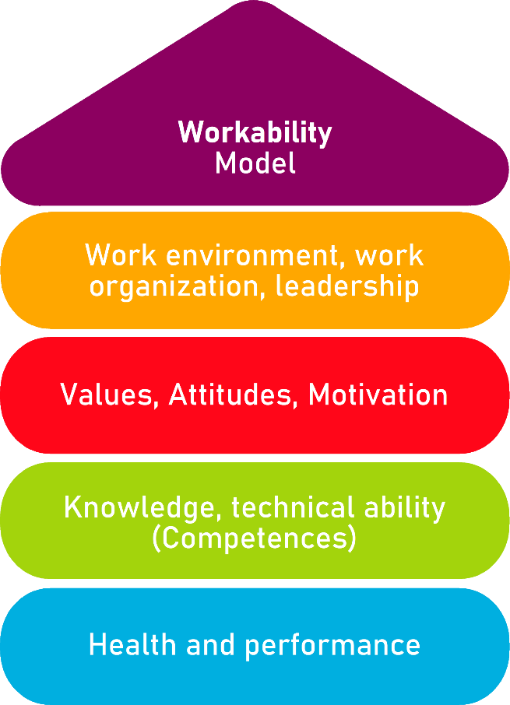

Tool 10

Employee appraisal

Description of the tool
The employee appraisal is used as a measure of personnel management. The exchange between supervisors and employees can take place in short and regular time intervals, but in practice there are often longer periods of time. Half-yearly or annual appraisals are used. Employees receive feedback on the status of the job as well as prospects for the coming months and years. At the same time, your own questions and concerns can be answered.
For managers, such an employee appraisal has the advantage that feedback (in both directions) can be given in a quiet atmosphere. Ideally, the employee appraisals are used to design and drive forward personnel development in a targeted manner.

Target group
Executives, owners and managing directors

Benefit of the tool
This guideline enables you to optimally design the framework conditions for your employee appraisals, to conduct the interview according to a guideline and to document it. If employee appraisals are held once a year, this enables future-oriented (personnel) work in your company.
Please describe in advance what you would like to achieve with the interview! This is also important for employees.
The goals of employee appraisals can be the following:
- Collect information about customers, projects, orders, etc.
- Identify the existing competencies of individual employees and the entire workforce, identify training needs and point out career prospects.
Dealing with acute crises and conflicts, e.g., within the workforce.

Duration
An employee appraisal lasts (depending on the need for an interview) about 1 hour and should not exceed this period if possible.

How to use the tool
The employee appraisal tool consists of 3 parts:
- General conditions
  - Please read the chapter Framework conditions first. Try to meet all the points mentioned. In this way, you create a good basis for ensuring that your employee appraisals are successful.
- The conversation in detail
  - All necessary questions of an employee appraisal are listed here. Read the process of the employee appraisal carefully in advance and consider which questions you would like to ask. Please note that the questions are only exemplary and should be changed or supplemented according to your specific operational requirements.
- The form for the interview
Use the interview form to document the interview.

- Framework

- Inform the participants of the employee appraisal at least 14 days before the interview.
- Choose the location for the conversation so that you can talk undisturbed.
- The involved person creates an overview of the topics that will be dealt with in the conversation in advance and make them known to the other involved people that everyone can prepare for it.
- Make sure that the conversation can be conducted in a calm and relaxed atmosphere, open and trusting, without time pressure and without interruptions. Create an open and honest atmosphere for conversation.
- As managing director, you moderate the discussion. This means that you welcome, clarify the time frame once again and ask the employee to explain his view on the agreed topic.
- If you as a supervisor are directly involved in a conflict, a neutral moderator is preferable.
- The conversation shares should be balanced (50:50). The conversation should be characterized more by recognition than by criticism.
- The agreements made in the interview must be documented in writing during the interview and then signed by both involved people. The transcript is to be treated as strictly confidential and remains at the personal office of the company.
- Separately from this, it is recorded at what time the employee appraisal took place and which measures (e.g., training requirements) can be derived from the point of view of the employee and the management.
- After you have had discussions with all employees, evaluate the documentation. Can unused skills, training needs, deficits in work processes, conflicts, etc. be identified?
- If you notice a need for action, plan appropriate measures. Make sure that concrete changes arise from the employee appraisals - even if they are small steps. When employees learn that they can make a difference, above-average commitment can be achieved.
- Employee appraisals should be conducted regularly (e.g., every year).

- The conversation in detail

- Please enter the following data at the beginning:
  - Date of the conversation
  - Name of the employee
  - Activity upon entry into the company
  - Activities of the employee today
  - Date of entry into the company
  - Additional qualifications
  - Reason for the interview (annual appraisal, job change, employee's wish, other)

- Discussion of the general company situation (report of the supervisor):
  - Economic situation
  - Organizational changes in the last year
  - Current goals of the company
  - Working atmosphere from the point of view of the management

- Career of the employee at the company (report of the supervisor):
  - Entry as ...
  - Career history
  - Qualifications
  - Particularities

- Services of the company for the employees (here the supervisor reports):
  - general
  - to the respective employee

- Discussion of the current tasks of the employee:
  - Employee's point of view
  - View of the company

- Self-assessment of employees – The following aspects are the content of this assessment:
  - What do I like best about my work?
  - What do I like the least?
  - What would I like to do in the future?
  - What is the most important thing in my work?
  - What about my workability?
    - Conducive and obstructive working conditions
    - Beneficial and obstructive aspects of the corporate culture / prevailing values and attitudes in the company
    - Required qualifications and, if necessary, unused competencies
    - Physical and mental health

- Evaluation of the current work of the employees (assessment and formulation of improvement requests of the supervisor)
It is about a critical (positive and negative) evaluation of the work of the employees in the last year. Here it makes sense to deal again with the goals that were agreed in the last employee appraisal.
  - Evaluation of the employee's current work
  - Assessment of the supervisor on the achievement of goals
  - Self-assessment of the employee on the achieved goals

- Contents of the target agreement are the following:
  - Date of the conversation
  - Names of the interlocutors involved
  - Concrete agreements and objectives
  - Time horizon and measurement criteria:
    - By when is the goal achieved?
    - Which measurand can be used to check it?
    - Which priority has which goal?
    - Concrete measures for the promotion / development of the employee (e.g.: further education, courses, task extensions)
  - Final statement and comments from employees and superiors
  - Signatures of employees and superiors

The jointly discussed goals/agreements are recorded in writing. This target agreement must be kept in the employee's personnel file.

- Employee appraisal form

1. General data
Date:
Name:
Date of entry into the company:
Function/ activity upon entry into the company:
Current function/activity:
Age:
Additional qualifications:
Reason for the conversation | - Annual Appraisal  - Job change  - Wish of the worker  - Other  What reason:

2. General company situation
- Economic situation of the company
- Organizational changes in the last year
- Current goals of the company
- Working atmosphere from the point of view of the management

3. Career of the employee in the company
- Entry as ...
- Career history
- Qualifications
- Particularities

4. Services of the company for the employees
- General
- To the respective employee

5. Actual work
Employee's point of view | View of the management
Deviations?

6. Selfassessment of the employee
- What do I like best about my work?
- What do I like the least?
- What would I like to do in the future?
- What is the most important thing in my work?
- What about my workability?
  - Conducive and obstructive working conditions
  - Beneficial and obstructive aspects of the corporate culture / prevailing values and attitudes in the company
  - Required qualifications and, if necessary, unused competencies
  - Physical and mental health

7. Evaluation
- Evaluation of the employee's current work
- Assessment of the supervisor on the achievement of goals
- Self-assessment of the employee on the achieved goals

8. Target agreement
Date of conversation:
Name of the employee:
Name of management:
Final statements/comments by the employee and the management:

SignatureEmployees n |  | Signature of the Management Board

Each of the interlocutors receives a copy of the target agreements. Both parties undertake to treat the contents confidentially.

The documents must be kept.

Target agreements – personal activity plan
What?
(What action is being taken?)
For what?
(Further specification of the measure and definition of goals)
Who is responsible?

Who supports?

In what period will the measure be implemented?

What are the costs for the realization?
Remarks
Source: The tool was developed within the project "AKKU". This project was funded by the Federal Ministry of Labour and Social Affairs (BMAS) as part of the Initiative Neue Qualität der Arbeit (INQA) and was professionally supported by the Federal Institute for Occupational Safety and Health (BAuA), Berlin. Leading project partners were: ZWH Düsseldorf, IST Wuppertal, d-ialogo Wuppertal, IAW (Institute of RWTH Aachen).

