Regulation of the work ability in small and micro enterprises through multimedia tools

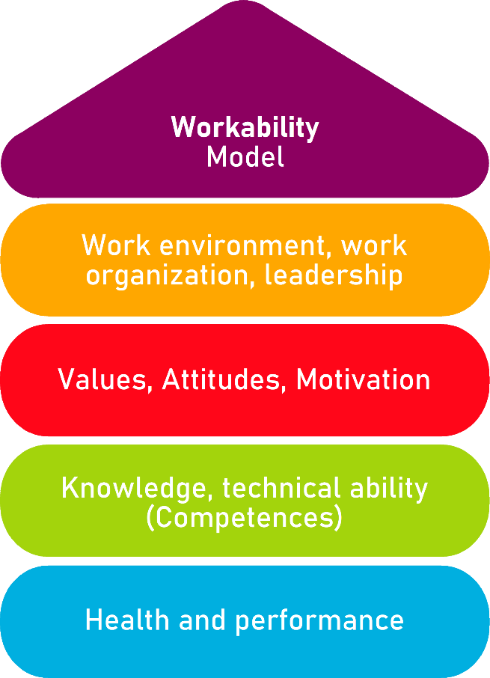

Tool 28
Labour risks and Prevention services

Description of the aim
The tool aims to inform employees and employers about the labour risk prevention service, to make sure that all rules are complied with, e.g., evaluations, delivery of material, training of employees. These are some of the aspects analysed in the tool, which is useful for the enterprise to know what procedures are needed for the safety of the workers and for the workers to know what they should receive.
Target group
Employers and employees from all sectors.
Benefit of the tool
The benefits of the tool are to improve the knowledge of companies and their workers on the prevention of occupational risks and to know the measures that prevention services comply with.
Duration
The tool can be developed in 20 minutes.
How to use the tool
The tool is presented as a checklist, the user will have to read the statements and tick YES or NO. If the answers are YES, he/she will know that he/she is complying with the necessary requirements, but if the answers are NO, he/she will have to look at the aspects that do not respect the necessary measures and act to change them.

Checklist | Yes | No
You have received training on labour risks and their prevention.
The risks of each work position have been analysed by a professional.
If the previous answer is yes, have you updated your workplace risk assessment?
The assessment of occupational risks includes checking the condition of the floor, walls, tools used, shared spaces, private spaces and toilets. All these elements have been assessed.
To facilitate the work, it is important that there is good lighting, that the temperature is suitable, and that the workplace is clean and tidy to avoid accidents. All these rules are respected in your workplace and have been assessed by a professional.
Doing a sedentary job in which you keep the same posture for a long time can lead to health problems. These problems have been explained to you and you know what they are.
In order to ensure the safety of their employees in the workplace, companies consult with companies specialised in labour risk prevention. The latter provide documents to the company that has contracted them, such as the "Prevention Plan" and the "worker's risk assessment". In addition, they are responsible for training the worker so that he knows how to deal with the labour risks that may occur. These measures are taken in your company.

Depending on the professional sector and work performed, employees will need PPE (Personal Protective Equipment). The company provides PPE to workers who need it and explains how to use it.
The company appointed to carry out the prevention service must meet with the employer to check that they have made the necessary changes to ensure that the workplace complies with the standards established to prevent labour risks. This action is carried out in your enterprise.
The company has received information material and a summary of the activities carried out by the labour risk prevention service.

Checklist: Action Plan
What is to be done? | How (procedure)? | Cost estimation | Priority | Until when? (date) | Who is responsible?
Read the statements | The user will have to read the statements and tick whether this action is carried out in his company by ticking the YES or NO boxes. |  | ☐ high  ☐ medium  ☐ low
Self-evaluation | At the end, you will have to find out which and how many are positive and how many are negative answers. |  | ☐ high  ☐ medium  ☐ low
Action | By analysing the negative answers, you will have to make the necessary changes to meet the requirement of the statement and be able to turn your negative answer into a positive one. |  | ☐ high  ☐ medium  ☐ low

