Regulation of the work ability in small and micro enterprises through multimedia tools

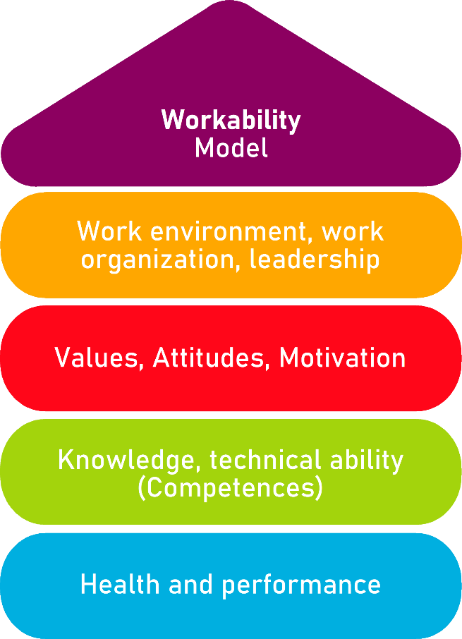

Tool 26
Workplace lighting

Description of the aim
This tool allows micro-enterprises, small business and potential entrepreneurs to understand how lighting installations in workplaces should be conditioned, so that they allow the correct performance of the workers without damaging their visual health. These types of aspects are sometimes overlooked, as specific knowledge is often required. This document offers a guide and questionnaires to understand and adapt lighting conditions to achieve a workspace adapted to the needs of your workers.
Target group
Employees and Small and Micro Enterprises Managers, entrepreneurs.
Benefit of the tool
Thanks to the guide and questionnaires offered, this tool allows to understand the lighting needs of a workplace, as well as guidelines and tests to make the appropriate corrections and evaluate the requests and needs of workers. We have to be aware of the importance of a good lighting conditioning, because factors such as performance, effectiveness and health of employees can be affected. Hence the need for this tool.
Duration
The next tool offers a series of tests and guides. Its approximate duration is 30-40 minutes, but can increase if workplace examination is needed.
How to use the tool
The next form is arranged in 4 sections.
1. Illumination guide.
2. Illumination questionnaire for the Entrepreneur.
3. Illumination questionnaire for the Workers.
4. Action Plan.
You must read carefully the explanations and guide offered, and then fill out the questionnaire, which will show out the strengths and shortcomings of our workplace. Afterwards, you should provide the employees with the specific questionnaire for them, and evaluate the needs to implement corrections.

Tool 26
Workplace lighting
Workplace illumination is a key aspect within the work space. Lighting does not only have an important impact on visual perception, but also on performance, effectiveness, fatigue and health of our workers. In long term, poor lighting can cause eye problems.
There are several aspects to consider when evaluating lighting; for example, quality and quantity or illumination system. These factors are often difficult to evaluate by non-specialists. Thanks to this document, you can understand the lighting conditions and needs of your workspace by using a guide and a few simple tests.

Illumination Guide
Sources | If available, a natural source of light is preferable to an artificial one.  If natural light is not available, it is advisable to use general artificial lighting. Localized lighting should only be used as a supplementary resource for more visually demanding tasks or when required by the worker.
Maintenance | Windows and skylights should be kept clean and clear.  In the case of artificial lighting, be aware of possible failures in the bulbs, like flickering, decreased or variable intensity over time. Even before the bulbs burn out, they can cause visual damage. In case of device failure, immediate repair is required, as well as periodic cleaning.
Level | We must prevent obstacles from obstructing light sources and creating shadows. If necessary, provide localized lighting. Levels should be adjusted until reading on devices and physical documents is comfortable (approximately 500 lux). The use of light-coloured walls (especially white) increases brightness. The arrangement of the luminaries should follow a correct distribution of the light flow. Below, is an image showing a lighting problem and two possible solutions.  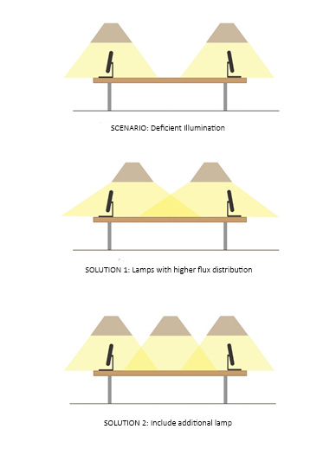
Glares | The light emitting element (window, bulbs…) must not be directly visible from the normal working position, and if possible, it should be out of the worker’s field of vision. This can be achieved by installing curtains on the windows or by placing the workstations perpendicularly to the window. This way, glare can be avoided.  When working with display screens or white walls, the light intensity should be lower.
Reflexes | Workplace surfaces (tables, desks) are advisable in matte appearance. Light must reach the workstations from the side.  Most current display screens have anti-glare options. If necessary, rearrange the workstation or light source, or include light diffusers.
Shadows | Again, light must reach from the side to avoid shadows. If there are localized light sources, they must be arranged in a strategic position so no shadows are created.
Colour Reproduction | We must include lamps that have colour rendering capability. In the following list, you have types of lamps related to their colour rendering capability:  -Standard incandescent: Excellent.  -Halogen incandescent: Excellent.  -High quality fluorescent: Very good.  -Current fluorescent: Good.  -Mercury (colour corrected): Mediocre.  -High-pressure sodium: Poor.  -Low pressure sodium: Monochromatic.
Light flashing | Older lamps should be replaced before they start to fail. It is advisable to use luminaires in "balanced mounting" (connection of the lamps of each luminaire to the three phases of the electrical network). We can check for possible failures in the power supply circuit.
Stroboscopic effects | The stroboscopic effect are optical effects produced when an object that moves rapidly and periodically is illuminated by flashes. We must replace old lamps, "compensated mounting" luminaires or use high-frequency electronic ballasts.
Visual Field | Redesign the stations so that the display screens are between 70º in the horizontal plane and 60º in the vertical plane, with no obstacles in the visual field.

Entrepreneur Form
Fill in this test about lighting conditions in the workplace. Then, evaluate the posible improvements and needs, and implement them to achieve a more adecuate workspace.

Entrepreneur  Form | YES | NO
Lighting Type
Natural  Illumination ☐ | General  Artificial  Illumination ☐ | Located  Artificial  Illumination ☐

Is there any type of maintenance and cleaning of the lighting systems?
Are there any blown or non-operational light bulbs?
Is the lighting at each workstation enough to perform the work without difficulty?
If working with display screen, is the light emitted by them adequate?
Have you received any complain about illumination from a worker?
Are there any illumination difference in the workspace?
Have your workers suffered any form of eyestrain repeatedly?
Are font shades and font sizes in documents (both virtual and physical) suitable for reading?
Are there many shadows in your workplace?
If needed, do workers have light regulation systems for their personal workplace?
Does the lighting system have sudden failures (flickering, blackouts...)?
Do the illumination or visualisation systems allow you to work in a comfortable posture?

Workers Form
Read carefully the next questions and choose the answer that adequate the most to your personal situation. In some questions, you can choose more than one option.

The lighting in my workspace is:
Excessive
Adequate
Deficient

The illumination in my workspace is:
Adequate
Annoying
Indifferent

Check the options you agree with:
I often suffer visual fatigue in my workspace.
Illumination fonts are often excessive/deficient.
The illumination fonts angle is uncomfortable.
The shadows in my workplace are annoying.
Contrast between colours and illumination in the workplace is uncomfortable.
There are flickering and blackouts in the lighting systems that make the work difficult.

After the workday, i feel (you choose more than one option):
Visual fatigue.
Blurred vision.
Tired eyesight.
Eye pain.
Migraines or dizziness.
Eyelids heaviness.

Note any observations or requests relevant to the lighting of workstations:

Checklist: Action Plan
What is to be done? | How (procedure)? | Cost estimation | Priority | Until when? (date) | Who is responsible?
Example: Change the burn out lightbulbs. |  |  | ☐ high  ☐ medium  ☐ low
☐ high
☐ medium
☐ low
☐ high
☐ medium
☐ low
☐ high
☐ medium
☐ low
☐ high
☐ medium
☐ low

