Regulation of the work ability in small and micro enterprises through multimedia tools

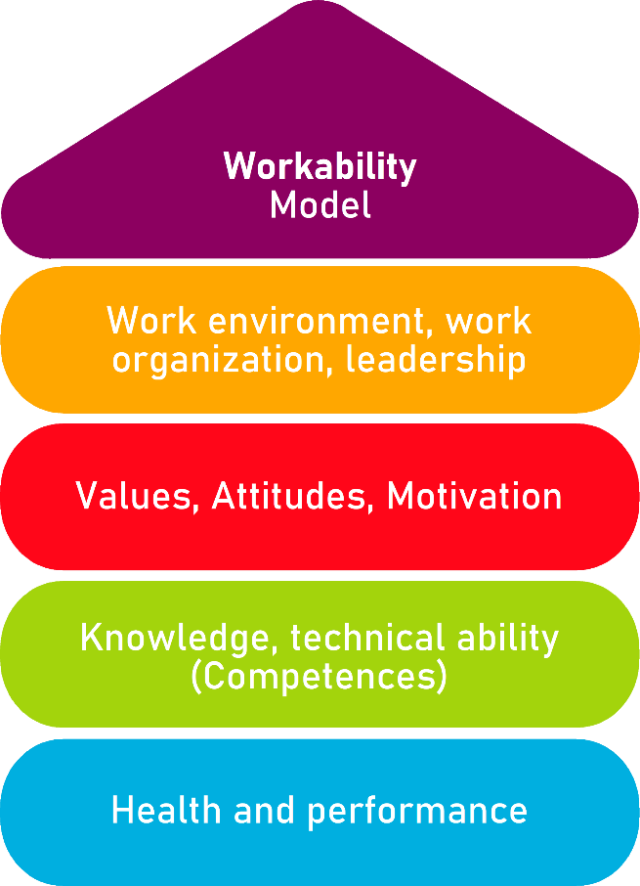

Tool 16
Checklist and recommendations
for safety at work

Description of the aim
In the following tables, readers will able the opportunity to familiarise with a very comprehensive sample of risks related to safety at work developed by the CIIP (Italian inter-association consultation for prevention).

The tool is formally divided into 5 conceptual areas:
- Prevention and work labour
- Prevention and work environment
- Prevention and organisational aspects
- Prevention and workability
- Mental health

Each area is declined in further focus dimensions so as to be as inclusive as possible of the many different variables and dynamics that intervene for each focus areas.

The tool is formally conceived to sustain management and/or owners in identifying the key areas of intervention to guarantee for their workers and employees a safe environment. As such it is to be intended as a referent and supporting tool.

Target group
Management, owners, external consultants specialised in health and safety at work, HR.
Benefit of the tool
This list of recommendations composing the hereby described tool can be applied to any organisational/geographical context and regardless of the industry, sector and dimension of the firm. The list of guidelines and their arrangement per category is very clear and user-friendly and it can be of great relevance for all the many different targets potentially invested in Quality Assurance processes
Duration
This is quite difficult to pre-assess, considering also that in this context ‘duration’ can have many different meanings and interpretations. For instance, in the case ‘duration’ refers to the time needed by management/owners to cross-check their compliance with the recommended guidelines, the process can be concluded in a matter of hours.

On the other hand, if with duration we refer to the time needed by the same people to align their organisation/functions to the recommended guidelines, this can take even week or months, depending on the planned changes and how time-consuming they are.

How to use the tool
Viewers are recommended to take vision of the tool for its revision starting from the first focus area and moving on with the followings, so as to avoid further layers of unnecessary complexity. Based on their own self-evaluation and estimates, management and owners (i.e. whoever is involved in the cross-checking process) can get a better sense on the most critical areas of intervention, where they feel that urgent actions are needed.

The implementation of this tools is very self-explanatory with high degrees of customisation based on the specific organisational context and operative setting. Below, we provide users a general framework for its actual deployment.
Checklist: Action plan
What is to be done? | How (procedure)? | Cost estimation | Priority | Until when? (date) | Who is responsible?
Re-adaptation  Re-configuration  Re-engineering | The ownership of the microenterprise needs to step in so as to address and intervene on those dimensions of risks to which they are significantly exposed to – in consideration also of their production systems, processing of raw material potentially highly dangerous for workers’ health (i.e., chemicals), etc.  The involved of professional personnel is highly recommended with trustworthy and reliable competences in the specific field of interest (i.e., prevention and safeguard from noise pollution) |  | ☐ high  ☐ medium  ☐ low

- PREVENTION AND WORK LABOUR
RISKS FROM UNCOMFORTABLE POSTURES
These risks can put excessive strain on the muscles, tendons, joints or heart, accelerating normal aging over time
Automation or auxiliaries (mechanizations, exoskeletons)
Avoiding extreme postures that reduce strength
Alternation between postures, especially if fixed where practicable (standing, sitting, semi-sitting)
Posture care; reduce the extent and duration of flexion of the lumbar and cervical spine
Non-sedentary lifestyle without overloads can delay the functional decline
RISKS FROM INTENSE PHYSICAL EFFORTS
These risks can put excessive strain on the muscles, tendons, joints or heart, accelerating normal aging over time
Reducing acute or cumulative overload from handling loads, efforts, postures, etc.
Eliminating maximal efforts and reduce prolonged efforts
Distinctions of maximum weights in ideal conditions for age groups in the manual handling of loads (e.g. ISO 11228-1 ISO TR 12295)
RISKS FROM REPETITIVE MOVEMENTS
These risks can put excessive strain on the muscles, tendons, joints or heart, accelerating normal aging over time
Reducing acute or cumulative overload from efforts, postures, repetitiveness at unsustainable rhythms
- PREVENTION AND WORK ENVIRONMENT
RISKS RELATED TO WORK ENVIROMENTS
These risks can cause premature musculoskeletal disorders or diseases, deafness, vascular diseases, tumors. The likelihood of these events increases over time with age and length of service.
Eliminating or reducing exposure to environments that are too hot, or too cold.
Improving the environment lighting: apply colour contrasts and additional grazing and/or localized lighting, eliminating glare and reflections
Eliminating or reducing as much as possible the exposure to toxic substances
Eliminating or reducing as much as possible the exposure to noise pollution
Amplification of sound alarms and/or supplementary light signals
Equipping workers with hearing protectors that are not excessively attenuating in order not to completely isolate them from alarms and communications
Eliminating or reducing as mush as possible the exposure to vibrations
- PREVENTION AND ORGANISATIONAL ASPECTS
RISKS RELATED TO ORGANISATIONAL ASPECTS
Working at atypical hours disturbs sleep, digestion, and the cardiovascular system. The effect increases over time with ageing.

Continuous interruptions do not allow the worker to use his experience to organize his work and manage recovery phases. A fragmented work, that is often interrupted by unexpected random events, does not allow the worker to manage its time and priorities
Improving the shift regime for everyone (rapid succession) and reducing or eliminating night shifts for the elderly, especially when they are perceived as more tiring and energy-demanding
Favouring measures for flexibility, self-management, part time regimes, removal from night shifts on request
- PREVENTION AND WORK ABILITY
RISKS REALTED TO COMPETENCES’ DEVELOPMENT
A monotonous job does not allow workers to learn new skills and can cause demotivation.
Tailoring and fine-tuning of training programmes in relation to workers and their specific occupation (i.e. what they might actually need)
RISKS RELATED TO COMPETENCES’ USE
Unexpected peaks in activity are harmful if not counterbalanced by recovery periods.
Strict top-down working methods prevent workers and employees from experimenting with their own skills and critical thinking
RISKS RELATED TO COMPETENCES’ TRASMISSION
knowledge comes in 3 different shapes:
- theoretical knowledge, which can be transmitted by training,
- know-how, which is the application of theoretical knowledge and can be mastered thanks to tutoring/mentoring programmes on site
- aptitudes, which means being able to carry yourself in the many different relational contexts. This type of knowledge is usually acquired by following the example of senior workers which have much more experience in relation to their occupation and team’s dynamics.
Cognitive functions decrease with aging, but at the same time they are usually compensated by greater know-how and experience
Sustaining bottom-up opportunities for training and education
Valorising commitment to training programmes and the acquisition of new skills from workers
- MENTAL HEALTH
PSYCHOSOCIAL RISKS
In the absence of margins for autonomous decision-making, the worker has the perception of not being able to rely on his experience. In the event of a relationship with the public or difficult customers, the worker is exposed to higher risks of social conflict. Lack of recognition and support are well known sources of stress in experienced workers
Favouring measures for flexibility, self-management, part time regimes, removal from night shifts on request
Avoiding open-space environments
Valorising groups as well as individuals
RISKS RELATED OT CHANGE MANAGEMENT
Embracing complexity as a resource, rather than a threat
Planning time and resources in great advance to ease the transition
Valorising the acquisition of new competences emerging throughout the process

