Regulation of the work ability in small and micro enterprises through multimedia tools

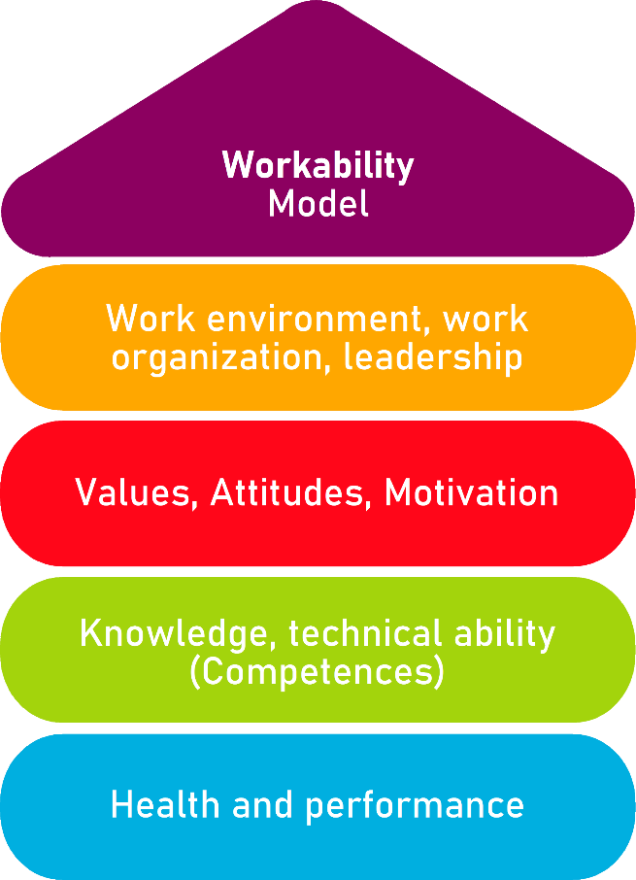

Tool 17
The IPAQ questionnaire

Description of the aim
The IPAQ (International Physical Activity Questionnaire) is a self-assessment tool developed by the IPAQ group. The questionnaire aims to help people in evaluating by themselves their level of physical activity. The categorical score model proposes three different outputs (i.e. ‘categories’):
- Low: this result is for people that do not engage quite at all physical activities of any kind
- Moderate: this result is for people practicing vigorous physical activity a minimum of 3 days a week OR 5 days a week of moderate-intensity physical activity OR 30 minutes per day of walk
- High: this result is for people practicing moderate-intense physical activity 7 days a week

The IPAQ Questionnaire is publicly available, in FREE and OPEN access: academics and scholars from all domain of science are highly encouraged to rely on it as methodological framework. The IPAQ Questionnaire comes in two different versions:

- Short version, recommended for small-piloting initiatives at local level OR in the case of “physical activity over the last seven days”
- Long version, recommended for large-scale research programmes OR in the case of “usual physical activity” (i.e. athletes, sportsmen/women)

In the context of the AKKU project, partners will propose the short version as much more suitable to the scope and scale of this Work Package.

Target group
All, with no distinction on gender and demography, let alone professional background and occupation
Benefit of the tool
In the context of the AKKU project, the IPAQ tool can be of strategic relevance to assess the average time that employees/managers spend in physical activity. The scientific literature correlating physical activity with better work performance is extremely rich in contributions. Based on results, management and/or owners of the organisation can develop, sustain and promote further guidelines/recommendations/internal policies to incentive healthy life style that can benefit workers/employees’ well-being and work ability.
Duration
The questionnaire should not take more than 15 minutes for respondents to complete.

How to use the tool
The questionnaire makes clear distinction between MODERATE and VIGOROUS physical activities:

- MODERATE physical activities: we mean activities that require a moderate amount of physical efforts and make you breath somewhat harder than normal
- VIGOROUS physical activities: we mean activities that require a large amount of physical efforts and make you breath with much more difficulty than normal

The distinction is very important since depending on the considered activity, inputs from respondents are processed in different ways.
Vigorous activities consume twice as METs as moderate ones: MET (metabolic equivalents) is the elementary unit used in health science to calculate body’s energy expenditure, and in simpler terms, the intensity of an exercise or activity. For instance, according to scientific standards:

- 1 MET = body at rest (i.e. sitting) = approximately 3,5 millilitres of oxygen consumed per kilogram (kg) of body weight per minute.
- 12,3 METs = jumping the rope
- Etc…

More in general:
- LIGHT physical activities < 3 METs
- 3 METs < MODERATE physical activities < 6 METs
- 6 METs < VIGOROUS activities

Respondents can calculate by themselves their average weekly METs following this very simple formula:

- METs VIGOROUS activities = minutes per day * days * 8 METs = XXX
- METs MODERATE activities = minutes per day * days * 4 METs = YYY
- METs from walking = minutes per day * days * 2,5 METs (slow); 3 METs (moderate); 3,3 METs (brisk) = ZZZ

Tot. METs per week = XXX + YYY + ZZZ

If respondents consume less than 700 METs/week → they are INACTIVE
If respondents consume between 700 and 2519 METs/week → they are SUFFICIENTLY ACTIVE
If respondents consume more than 2520 METs/week → they are ACTIVE or VERY ACTIVE

By answering to the following survey, You have the opportunity to assess and evaluate the kinds (and quality) of physical activities that You do on a weekly basis. Please, proceed to answer even if you don not consider yourself an active person: think about the activities you carry out at work, at home (i.e. gardening and house cleaning), walks to get from place to place, etc.

The questions will ask you about the time you spent being physically active in the last 7 days. Please answer each question even if you do not consider yourself to be an active person.

Checklist: Action plan
What is to be done? | How (procedure)? | Cost estimation | Priority | Until when? (date) | Who is responsible?
Foster and promote an organisational culture that awards and reinforce self-wellbeing, mindfulness and both mental and physical fitness | Set up an incentive framework for workers that adopt and embrace new routines and habits that support them in overcoming their sedentary lifestyle (e.g., all Fridays workers are allowed to leave from the office two hours before the traditional schedule if they come by bike) |  | ☐ high  ☐ medium  ☐ low

VIGOROUS ACTIVITES:
Please, try to think about all the vigorous activities that you performed in the last 7 days. By VIGOROUS activities we mean activities with high-physical demand that consumed your breath faster than normal. Think only about vigorous activities that took at least 10 minutes at a time.
- During the last week, how many days did you do vigorous physical activities (e.g. physical exercise, heavy lifting, running, etc.)?
- ______day(s) per week
- I did not do activities of such kind ◻️, skip to question 3
- How much time did you spend doing vigorous activities on one of those days?
- ______ hours per day
- ______ minutes per day
- I do not know ◻️
MODERATE ACTIVITES:
Please, try to think about all the moderate activities that you performed in the last 7 days. By MODERATE activities we mean activities with light-physical demand that made you breath harder than normal. Think only about moderate activities that took at least 10 minutes at a time.
- During the last week, how many days did you do moderate physical activities (e.g. bicycling, carrying light loads, etc.)?
- ______day(s) per week
- I did not do activities of such kind ◻️, skip to question 5
- How much time did you spend doing moderate activities on one of those days?
- ______ hours per day
- ______ minutes per day
- I do not know ◻️
WALKING:
Please, try to think about the time you spend walking in the last 7 days (e.g. from work to home, and vice versa, for pleasure, sport and/or recreation)
- During the last week, how many days did you do walk for at least 10 minutes?
- ______day(s) per week
- I did not do activities of such kind ◻️, skip to question 7
- How much time did you spend walking on one of those days?
- ______ hours per day
- ______ minutes per day
- I do not know ◻️
SITTING:
Please, try to think about the time you spend sitting in the last 7 days (e.g. doing homework, studying, reading, lying down, etc.)
- During the last week, how much time did you spend sitting?
- ______ hours per day
- ______ minutes per day
- I do not know ◻️

