Regulation of the work ability in small and micro enterprises through multimedia tools

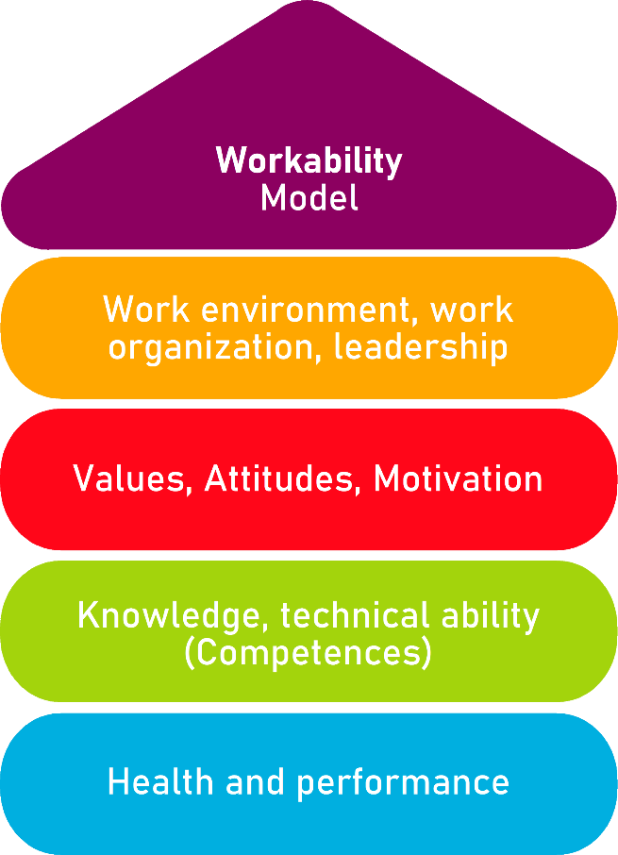

Tool 21
Return to work process

Description of the aim
This tool allows the users, based on their position in the enterprise, to understand the very meaning of the return to work process after a health problem or injury. This document helps reducing the time of further delaying of return to work process. The document offers a return to work guide and questionnaires for each profile to assess their knowledge and at which point in the process they did not pay any or enough attention, so they can adapt to the needs.
Target group
Employee and Employers
Benefit of the tool
Thanks to the offered guide and questionnaires, this tool will allow users to understand the return to work process, as well as to check if they ever encountered any step from the process, to know and to be able to take any of the steps for further use. The tools itself is raising the awareness of the importance of every step in the return to work process, because all of them together contributes to the success.
Duration
The tool offers a guide and questionnaires for each profile. For each profile the approximate duration is 30 minutes, but can be increased if further notes are needed.
How to use the tool
This tool is sorted in 5 sections:
1. Return to work guide for Employee
2. Check form (questionnaire) for the Employee
3. Return to work guide for Employer
4. Check form (questionnaire) for the Employer
5. Action Plan
After you choose a profile, you must read carefully the explanations and guide offered, and then fill out the questionnaire form, which will show your experience related to the return-to-work process. Afterwards, each profile can evaluate the needs to implement corrections if needed.

Tool 21
RETURN TO WORK PROCESS
Preventing workplace injuries and illness is the responsibility of everyone at the workplace. But when injuries and illness do occur, however, it is important to minimize the human and financial impacts by focusing on getting the worker back to safe and productive work as soon as medically possible.
Return to work is a process of the employer and the employee, for safely returning of the employees to the workplace in a timely manner. The goal is to return the worker to their pre-position through complete collaboration between employee and employer.
Thanks to this document, each profile can understand the importance of each step of return to work process by using a guide and a few assessment questionnaires.
PLEASE CHOOSE PROFILE :
 | ☐ |  | ☐
Scroll to the employees return to work guide |  | Scroll to the employers return to work guide

Return to work GUIDE for EMPLOYEE
If you are recovering from a health problem or injury, you can benefit from returning to work as soon as physically and safely possible. Work can be therapeutic and it can support you in your recovery. Moreover, the longer you are out of work, the harder it is to go back, both physically and mentally, and the higher your chances of developing a long-term incapacity.
Legal obligation | Firstly you should know that as an employee you have rights in regards to the returning to work, also you should know about the company’s return to work policy if you suffer injury or develop an illness.  Your employer has a legal obligation to treat all workers equally and to provide reasonable accommodation for people with disabilities, illness, injuries etc. This means that employers have to take appropriate measures to enable a person with a disability to have access to and participate in employment.  Those returning to work after more than seven days' leave may receive an appropriate health note for individuals if their health affects their ability to work. This note will help identify and to delegate job tasks that can be performed in the specific job position.  Employers are legally obliged to treat people equally in employment and occupation, including adapting the workplace to the disability, for example adapting premises and equipment, patterns of working time, the distribution of tasks, or the provision of training or integration resources.
Reporting | You should report an injury to a supervisor as soon as it happens, answering any questions honestly.  The more information you share you will be better understood.
Participation | As an employee, you should actively participate in the development and management of Return to Work plan.  You should make every effort to follow the plan of returning to work, advising of any difficulties or changes throughout the process.
Communication  and Cooperation | In terms of communication, openly and honestly communicate to all parties throughout the process, including your employer, Return to work coordinator, doctors and other significant person. Open communication is a key to returning to work sooner.  Cooperation between employee, employer, healthcare provider and the health and safety representative leads to successful return to work.  Shared information between all, leads to developing return to work plan, based on what you are able to do.  If it is a longer sick leave, communication should be from the very beginning of reporting.  This may include:  - Making regular phone calls or emails  - Asking to be kept up to date with what’s happening at work  - Agreeing on what details of your illness or disability can be shared with your colleagues and what should be kept confidential
Advice and methods | The employee should comply with all advice and should use correct work methods. Why so? Because if the injury is physical, you should follow correct ergonomic procedures and correct work methods, so to ensure your injury is not aggravated further. If the injury is psychological, ensure you voice any concerns, stressors or problems with the Supervisor as soon as they occur, so that solutions can be put in place and to avoid further injury or illness.  Also, you should always follow the advice of treating practitioners and doctors, not to neglect them in the process.

Employee check form
Fill in this form about return to work process as an employee into a workplace. Then, evaluate the posible improvements and needs, and implement them to achieve a long-term stay in a workplace.
Employee  Check - Form | YES | NO
Did you ever found yourself in situation to encounter with the legal obligations when returning to work process ?
Did you ever report any injury or illness where in the process of return to work ?
Have you ever participated or followed any return to work plan ?
Has there been any communication or cooperation in regards to the process of returning to work?
Have you received any complain about return to work process from an employer ?
Have you ever followed any given advice and methods from relevant person in the process of returning to work ?
Have you encountered problems following or not following the advice and methods of relevant people in the process of returning to work ?
Do you have any suggestions to be applied in regards to the improvement of the return to work process ?
If yes, please explain:

Return to work GUIDE for EMPLOYER
Successfully managing workers' return-to-work after a health problem or injury is beneficial for every employer. The act of setting up a successful return to work of employees, helps to reduce the costs of lost productivity, also of recruiting and training new staff to cover the role. This can make the company to build morale values in the workplace by showing all workers that the injured workers are valued. Another benefits is that the loss of productivity is kept to a minimum and reduction of costs for recruitment and training of new workers.
Legal obligation | Long-standing health problems and disabilities become more common with age.  Employers will benefit from supporting people to return to work as quickly as advisable after an injury or illness, helping employees with chronic health conditions to remain in work and to help employees with chronic health conditions (chronic illness) stay at work. Because of the financial support they will provide, they are securing and building a higher reputation in the workplace.  Those returning to work after more than seven days' leave may receive an appropriate health note for individuals if their health affects their ability to work. This note will help identify and to delegate job tasks that can be performed in the specific job position.  The provision of measures to accommodate the needs of disabled people at the workplace plays an important role in combating discrimination on grounds of disability.  As an employer, you are legally obliged to treat people equally in employment and occupation, including adapting the workplace to the disability, for example adapting premises and equipment, patterns of working time, the distribution of tasks, or the provision of training or integration resources.
Development Policy | You should develop integrated return to work policy in the company based on safety and health; sickness absence management and disability policies.  The policy can set out details concerning, for example, the roles and responsibilities of the actors involved, procedures around communication arrangements with the employee, and workplace adaptation measures.
Early detection and support | The chances of successful return to work are far greater when measures are taken at the beginning of the absence period. The focus should be on accommodating employee’ health problems so that they can return to work as soon as possible.  Reporting an injury, incident or illness to the insurer as soon as possible, is more likely that you will have the employee back to work sooner.  Also you should offer support, its important to remember that the employee also will have a growing list of concerns, and is good to give a positive encouragement and understanding of the situation throughout the process, helping the employees to feel they are supported. Keep their needs, and put some answers in action.
Communication  and Cooperation | In terms of communication you should ensure regular communication.  This may include:  - Making regular phone calls or emails  - Keeping them up to date for what’s happening at work  - Agreeing on details what should be shared in the company and what should be kept confidential  Communication should be maintained while the employees are off work and when they are into process of returning to work, and this is crucial for gaining positive response and willingness from the employeе to get back to work, as soon as possible. As with the support, communication reaffirms to the employee that they are valued and appreciated.  Although the communication involves various people, from the employee, employer, management and health advisor, to the treating physician, social insurer, and training institute, and despite having different responsibilities in the process, everyone needs to share the common objective of a quick and effective sustainable return to work.  You should involve the employee in the return to work plan. The employee should have a voice into the goal of the plan which should focus on current capabilities, breaks and work hours.
Individualised solution | Measures to reintegrate the employee should be tailored to his/her needs and abilities rather than ‘one-size-fits-all’. Reduced hours, adapted workstations, adjusting work demands, all of them should be designed according to what the individual can do.
Capacity or Incapacity | While work capacity may have changed, it is more useful to keep the focus on the person’s remaining skills and abilities, and re-design their role around that.  The purpose of alternate duties is so that employee can recover at work, not only saving money on lost time and efficiencies, also ensuring that employee is improving their functional capacities via movement and maintaining positive mental health.
Comprehensive measures | Interventions should consider the bigger picture. Everything from conditions in the workplace to social and personal factors should be taken into account (e.g. travel burden associated with treatments, level of cooperation among work colleagues, etc.).  Also, preparing other employees for the employees return should be considered. Anxiety and nerves are common in employees who have been off work for some time. Its important to make the employee well supported, ensuring awareness of the returning of the employee between staff, also about the changes to the role, so everybody can offer support and encouragement where possible.

Employer check form

Fill in this form about return to work process as an employer into a workplace. Then, evaluate the posible improvements and needs, and implement them to achieve a long-term stay in a workplace.
Employer  Check - Form | YES | NO
Do you know about the importance and benefits of addressing the Return to Work process ?
Did you encountered challenges or problems regarding the legal obligations during the returning to work process of the employees ?
Does the company follow any return to work plan ?
Does the company posses any return to work plan ?
Do you already have developed any return to work policy in your company?

Have you received any complain about return to work process from an employeе?
Have you ever reported any injury, illness or maintained early detection measures to the competent authorities ?

Have you offered necessary support to an employee in the process of returning to work?
Have you maintained proper communication and collaboration with the employee during the return to work process?

Do you apply individual approach towards employee in the return to work process ?
Do you focus on adaptable capacities of the employee in the return to work process ?
Have you included in the return to work process all the comprehensive measures?
Do you have any suggestions to be applied in regards to the improvement of the return to work process ?
If yes, please explain:

Checklist: Action Plan
What is to be done? | How (procedure)? | Cost estimation | Priority | Until when? (date) | Who is responsible?
Example: Communication and cooperation |  | ☐ high  ☐ medium  ☐ low | ☐ high  ☐ medium  ☐ low
Comprehensive measures |  | ☐ high  ☐ medium  ☐ low | ☐ high  ☐ medium  ☐ low
 |  | ☐ high  ☐ medium  ☐ low | ☐ high  ☐ medium  ☐ low
 |  | ☐ high  ☐ medium  ☐ low | ☐ high  ☐ medium  ☐ low
 |  | ☐ high  ☐ medium  ☐ low | ☐ high  ☐ medium  ☐ low

